OPERATIONS PERFORMED AS ADMIN AUTHENTICATIONS:

ROLE: ADMIN

1. **Structure Of Project:**

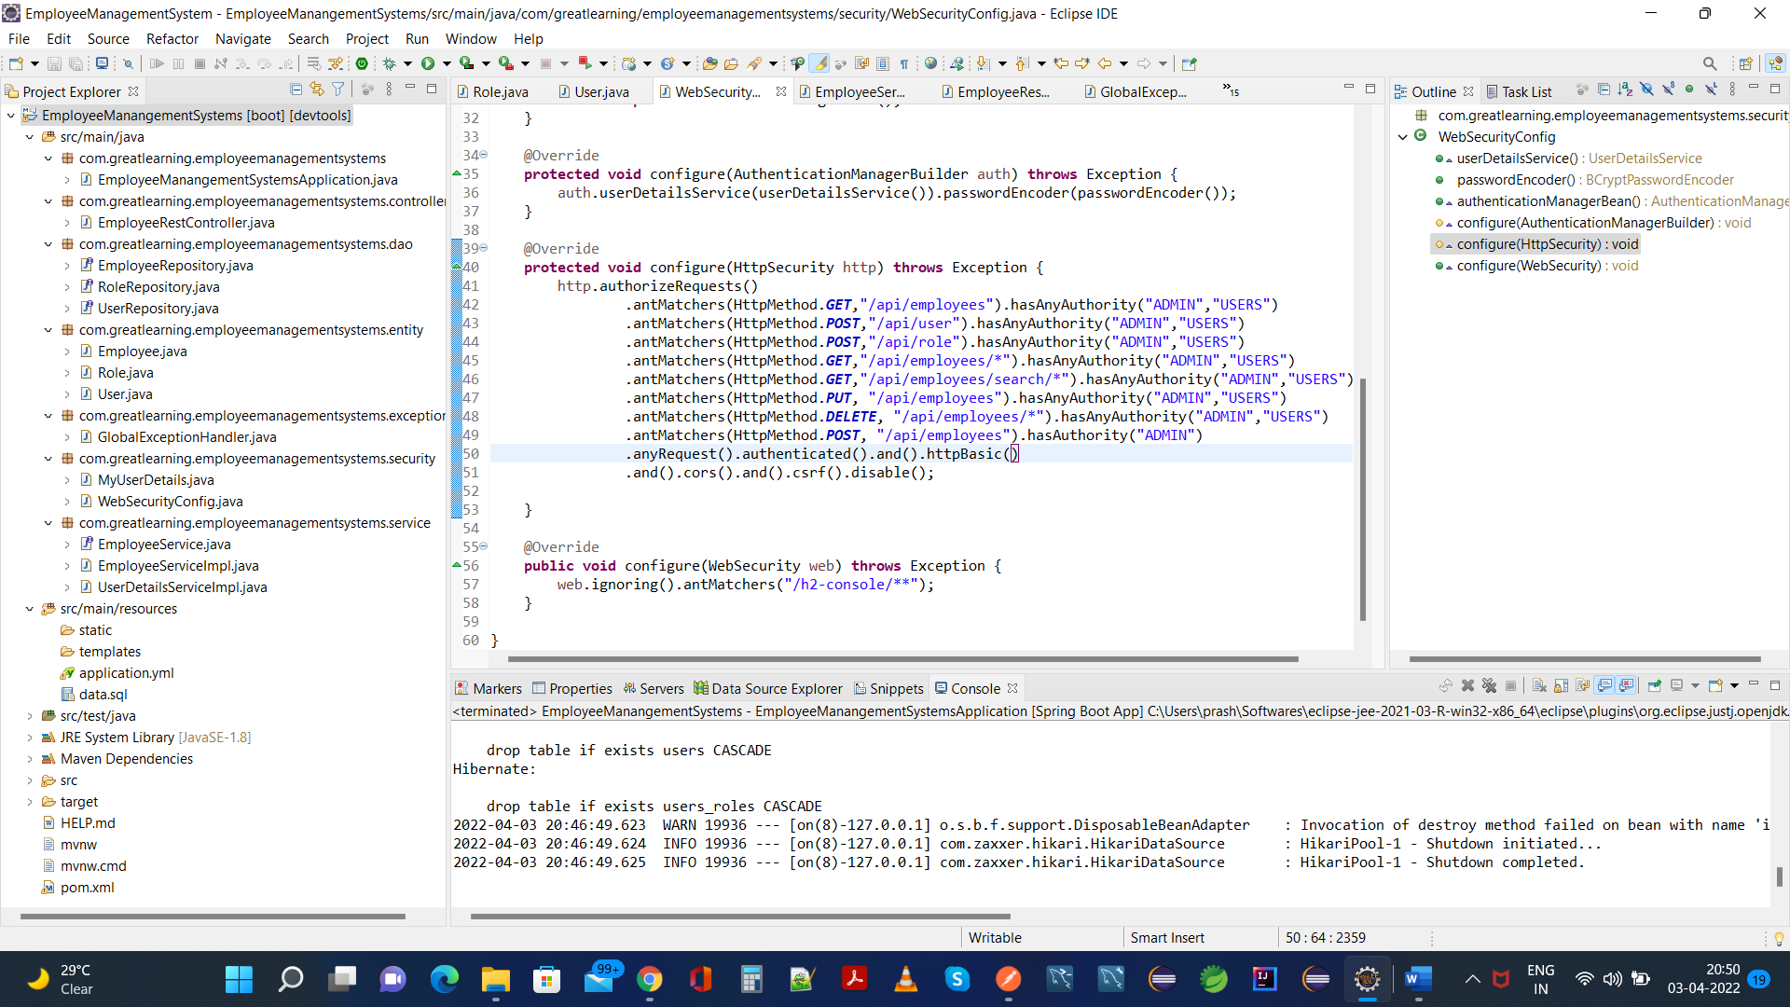

1 (a) Admin Creates Role as User:

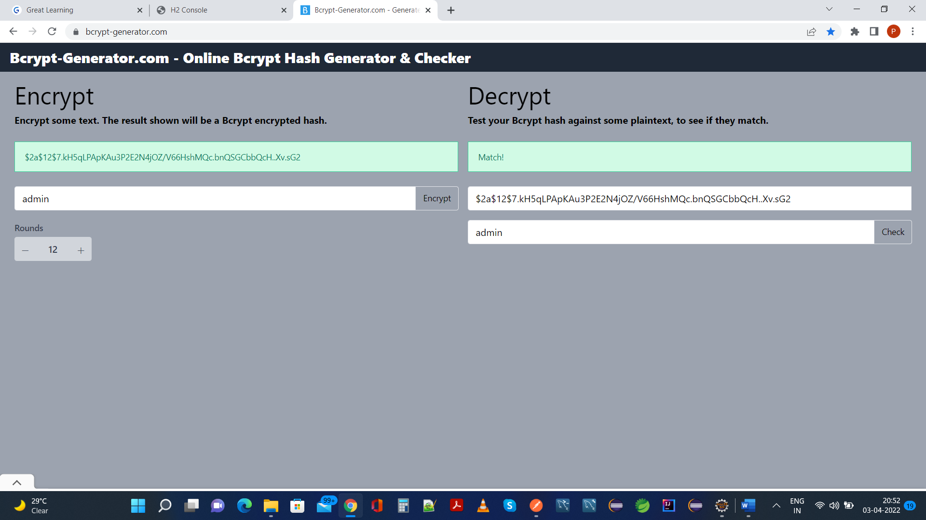

1(b) User Role:

**.**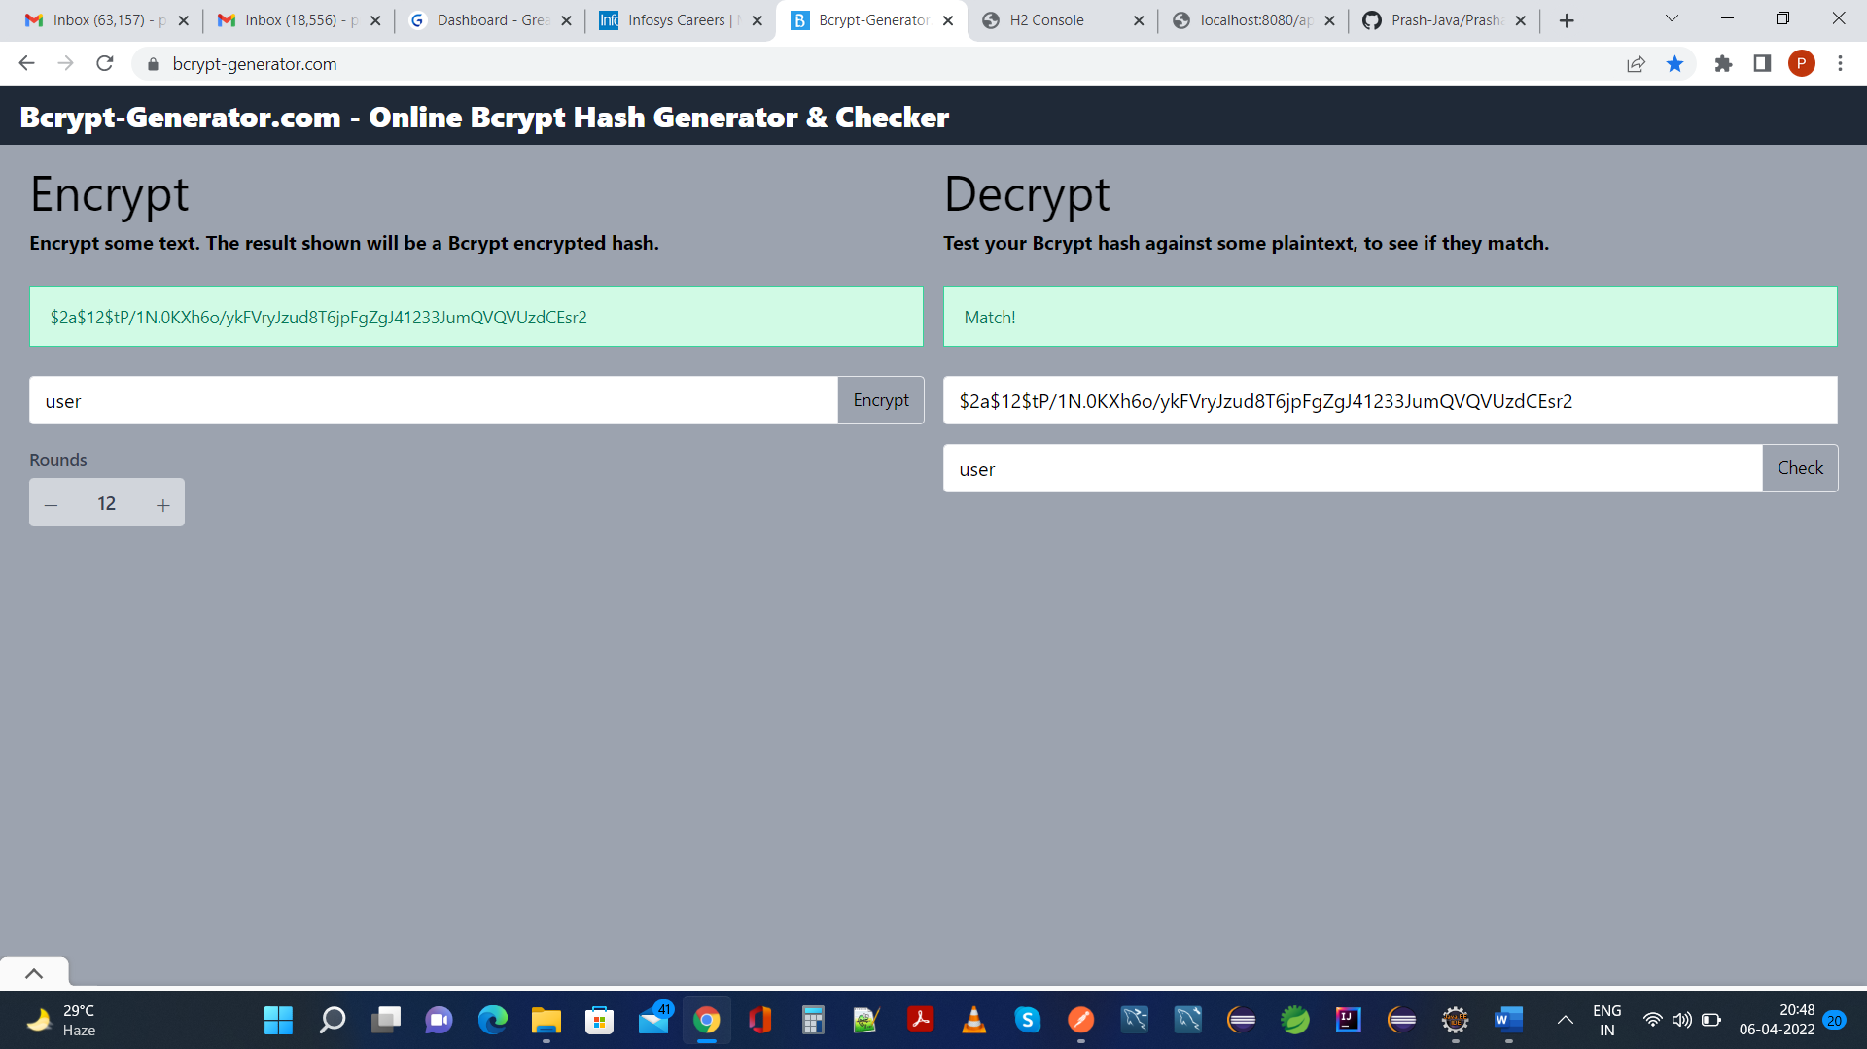

1 (c) Initial Stage of Application Before Start:

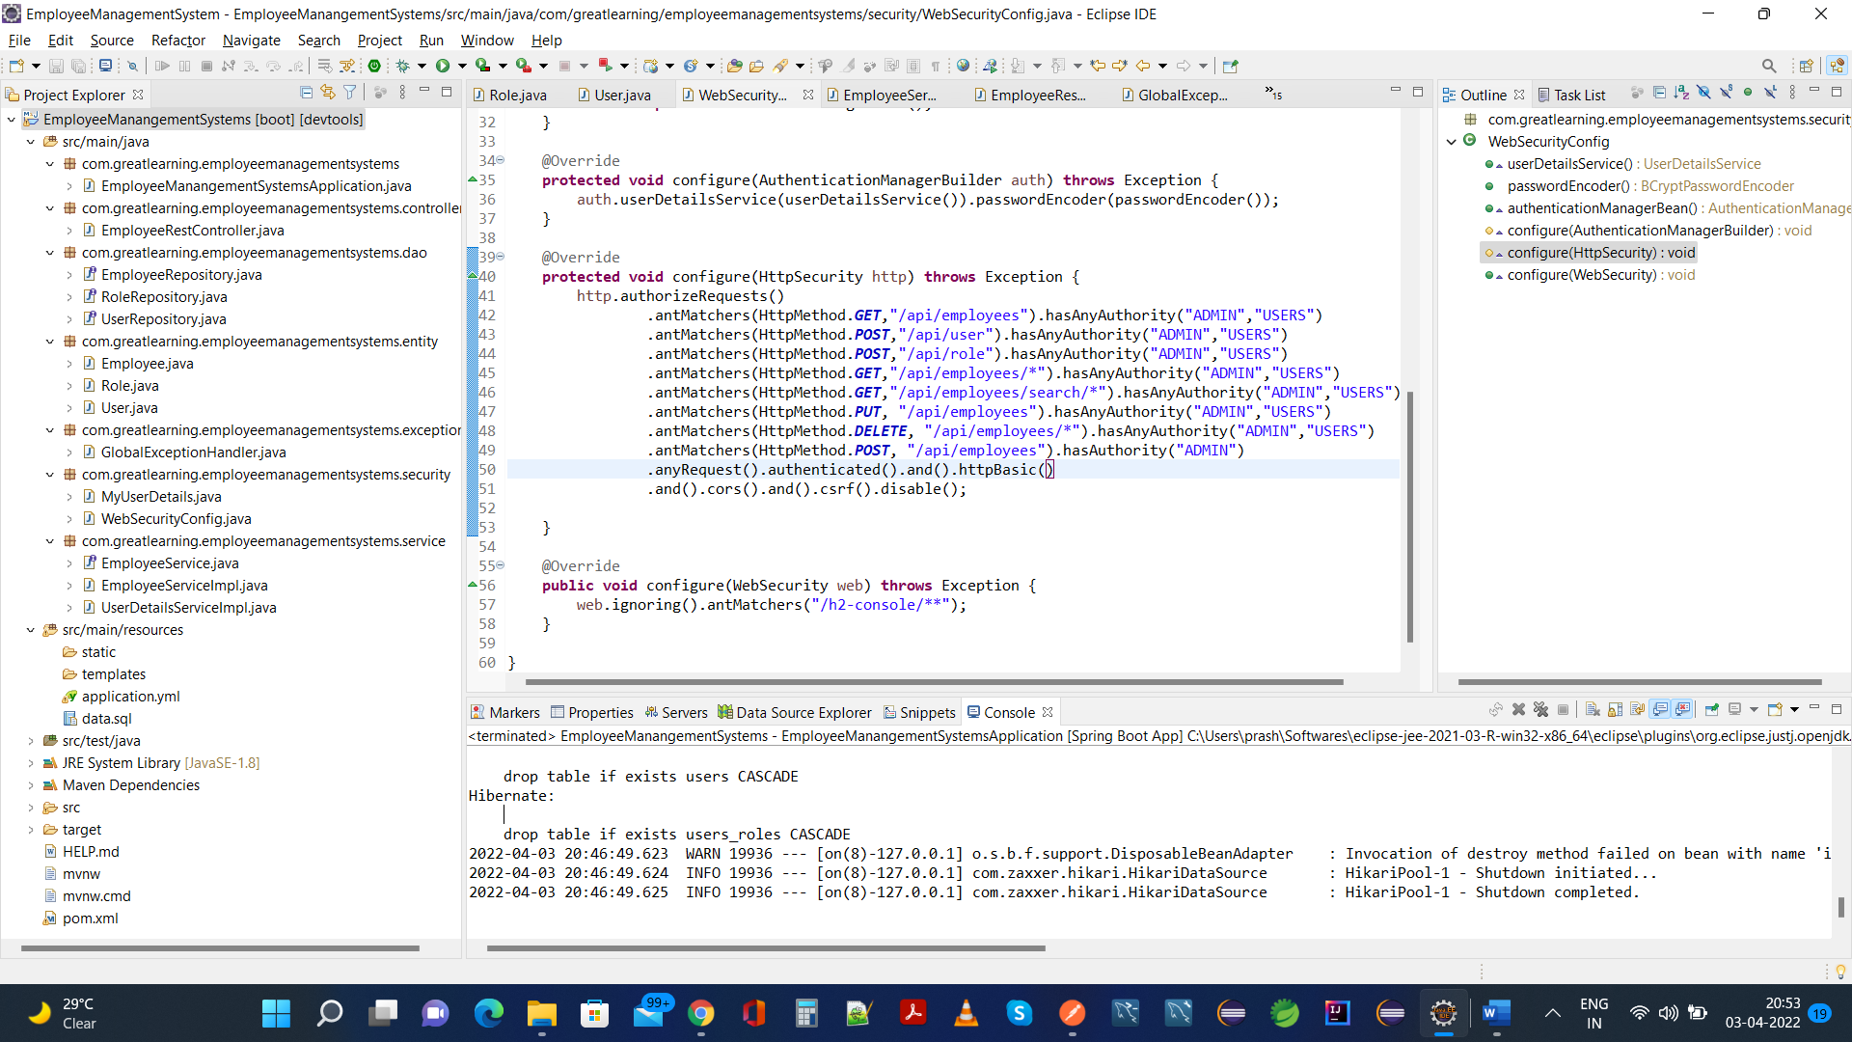

1(d) Data.sql is populated as follows:

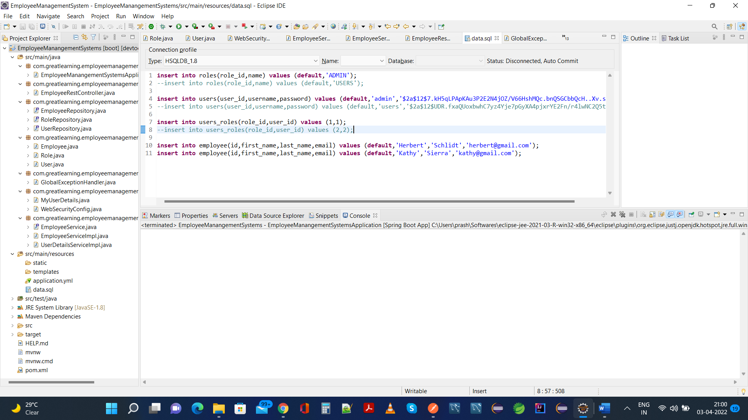

1 (e) Application.yml File Configuration:

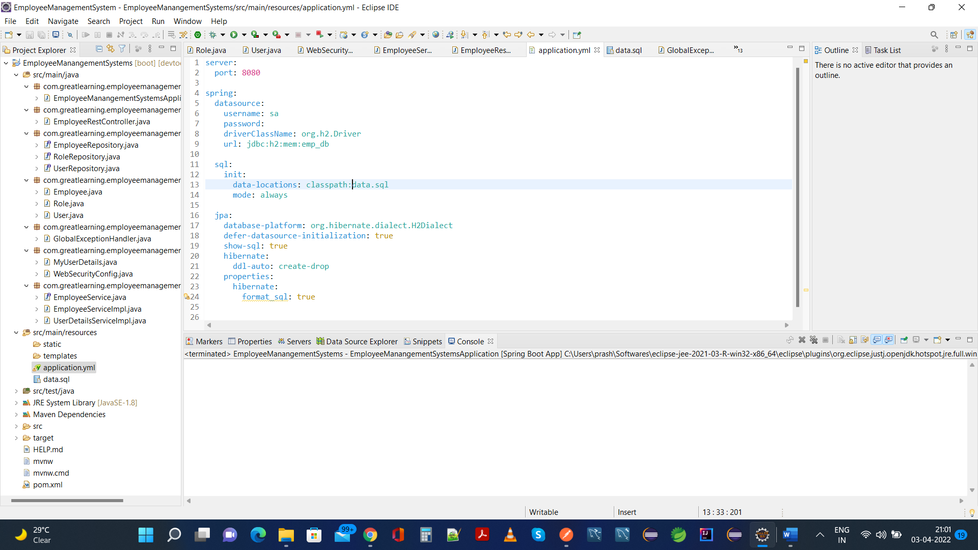

**Starting Application As Spring Boot App:**

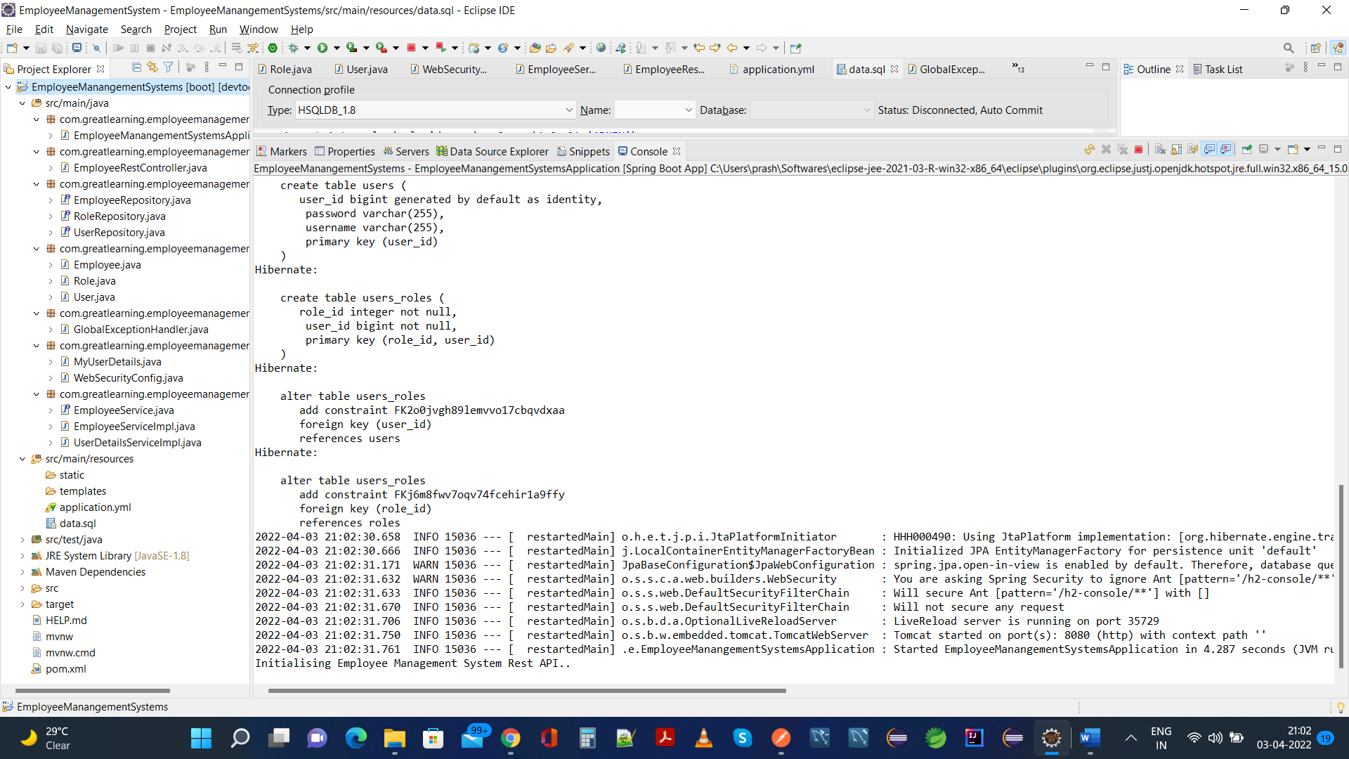

**Structure of H2 Database Created Using Spring-JPA:**

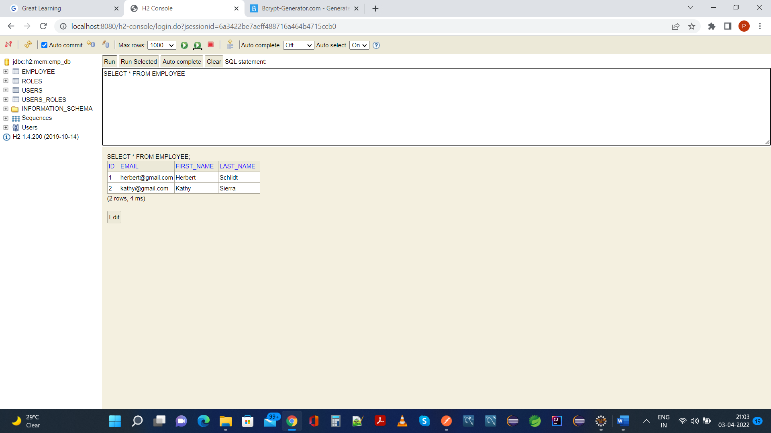

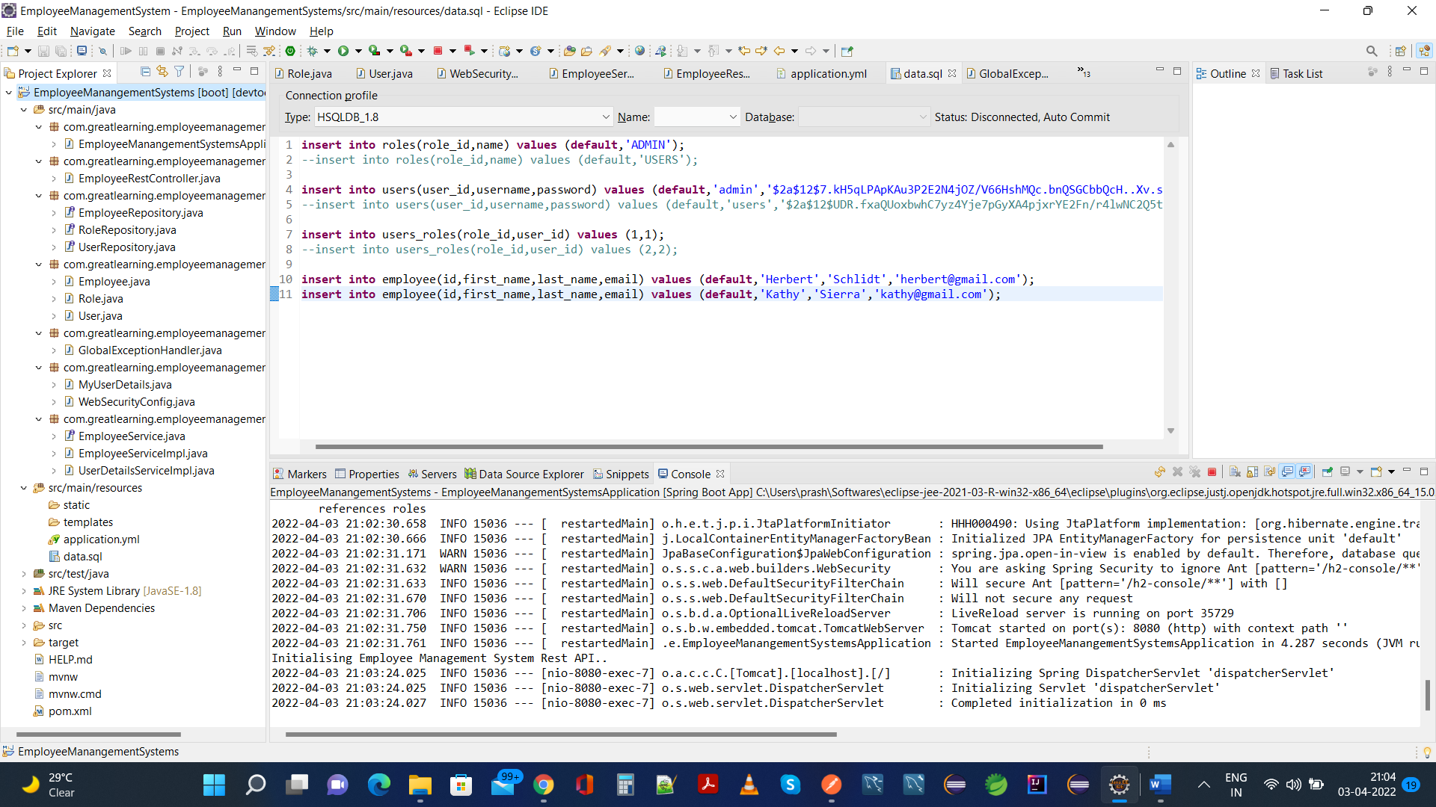

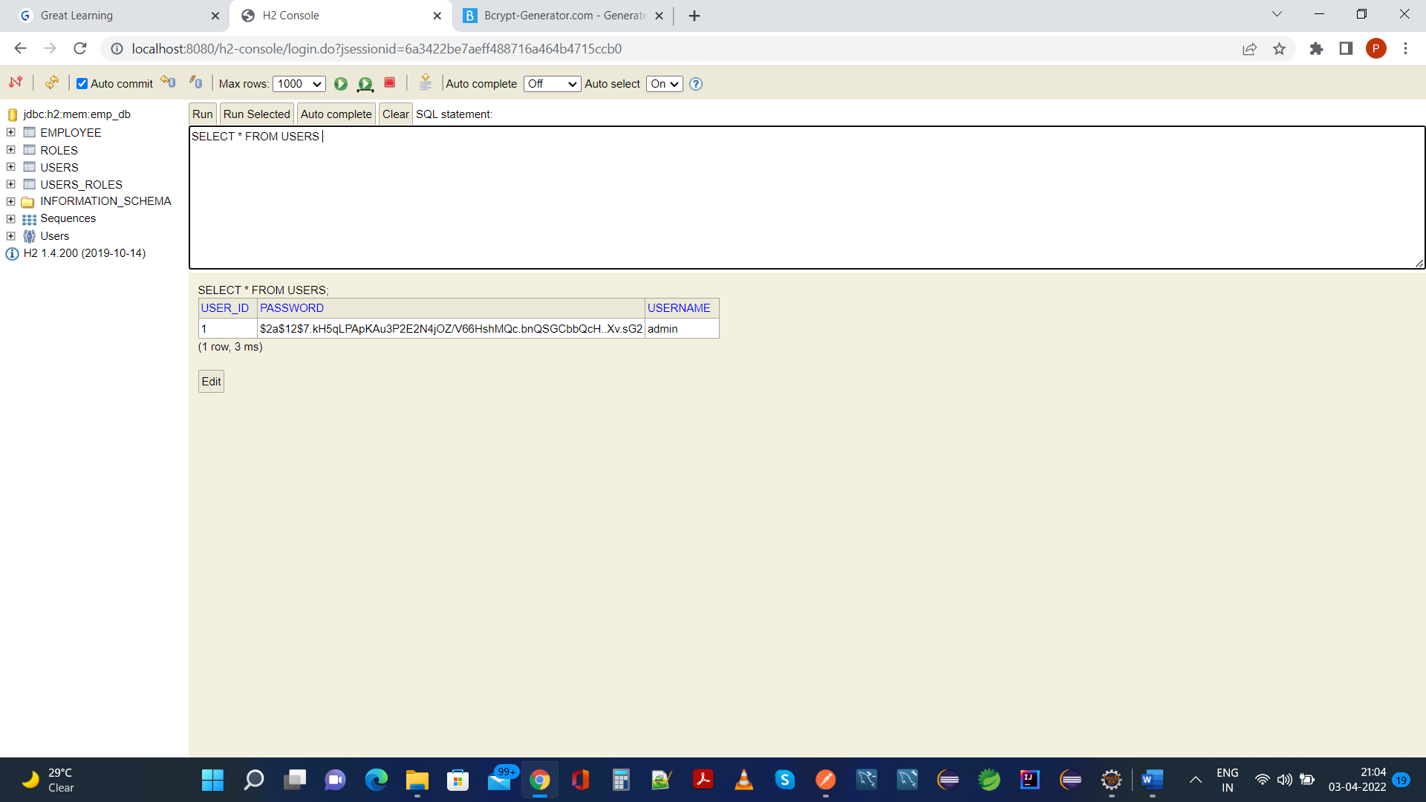

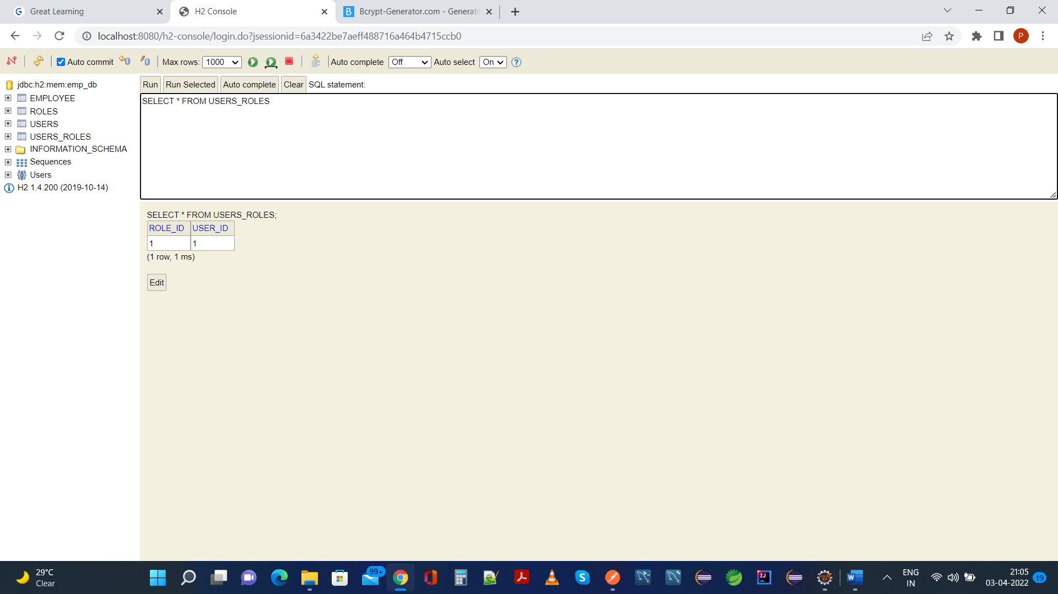

**2. Your application should be able to add roles in the database dynamically in the db.**

**Logging In As Admin Role In Postman And Fetching Employees:**

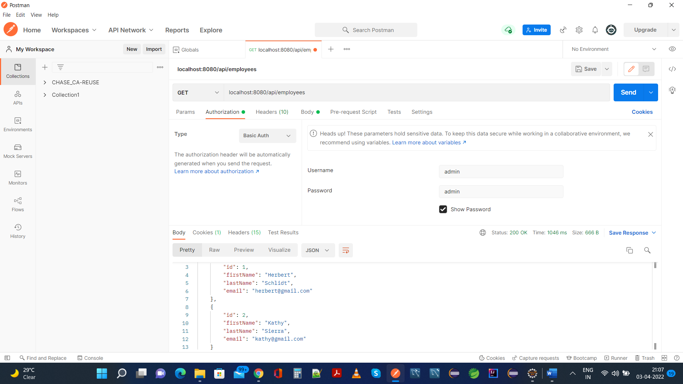

**Creating a New Role as USER:**

**Postman:**

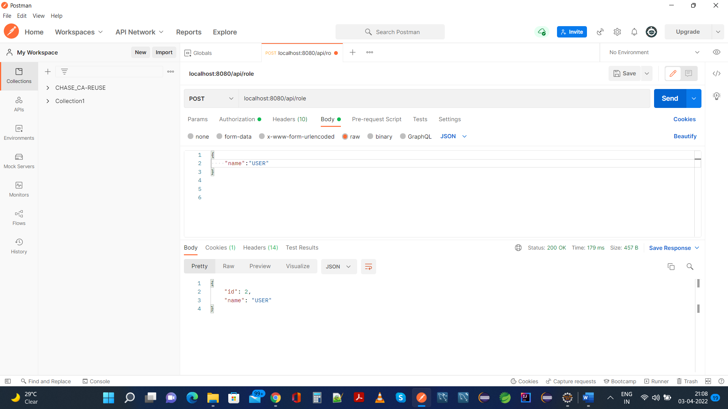

**H2 Database, Created Role User Is Added:**

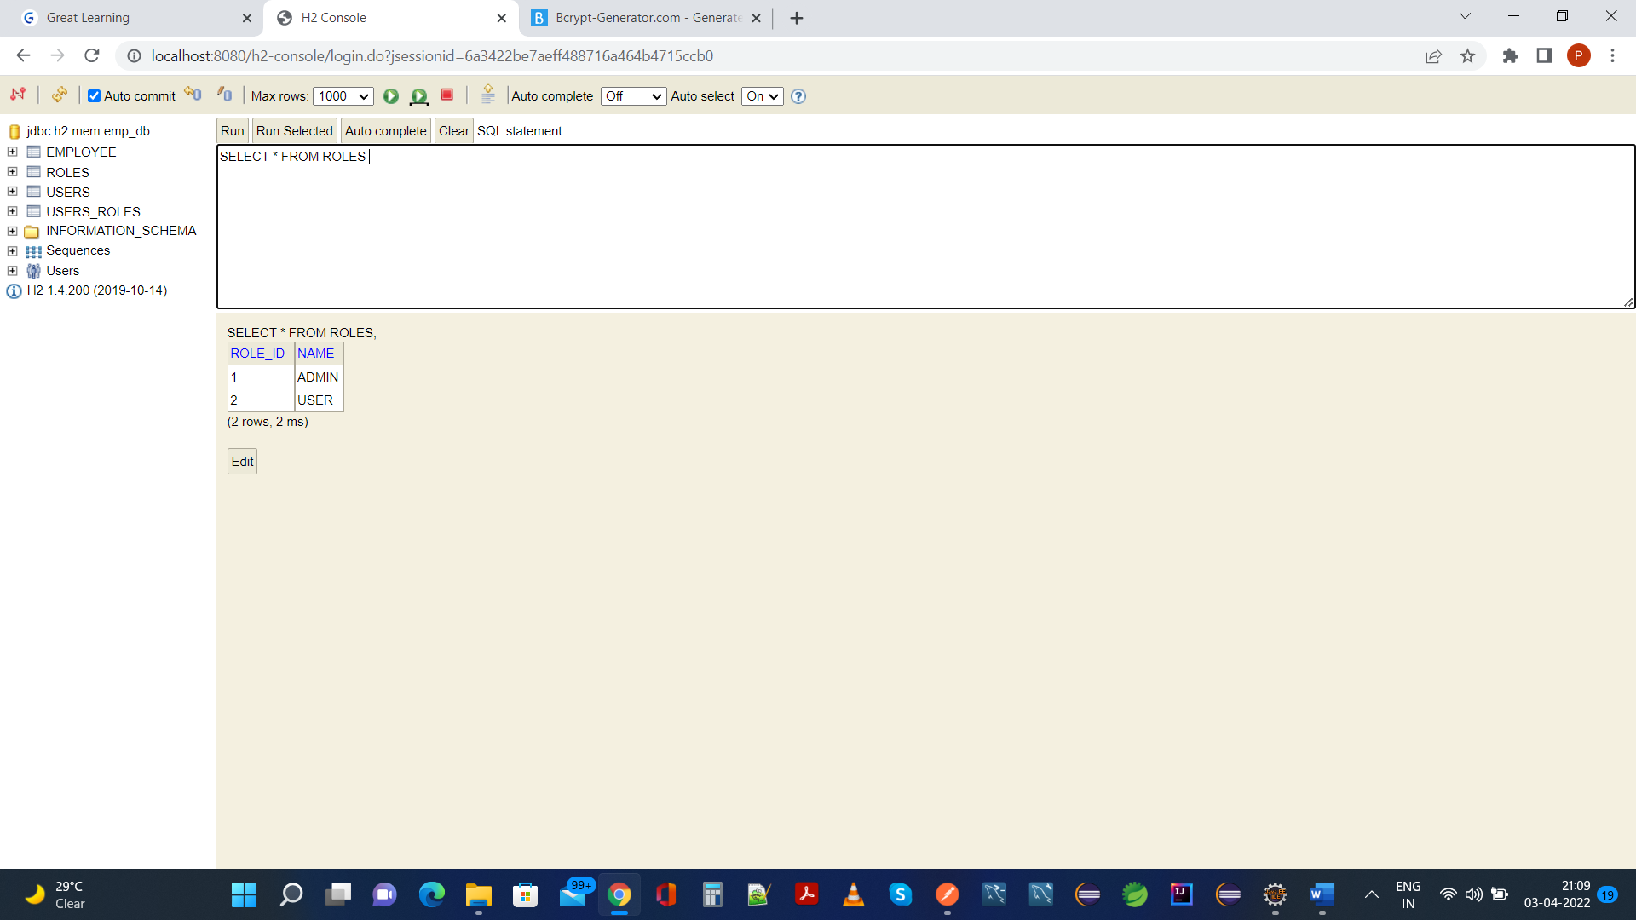

**3. Your application should be able to add Users in the db which can be used for authentication purposes**.

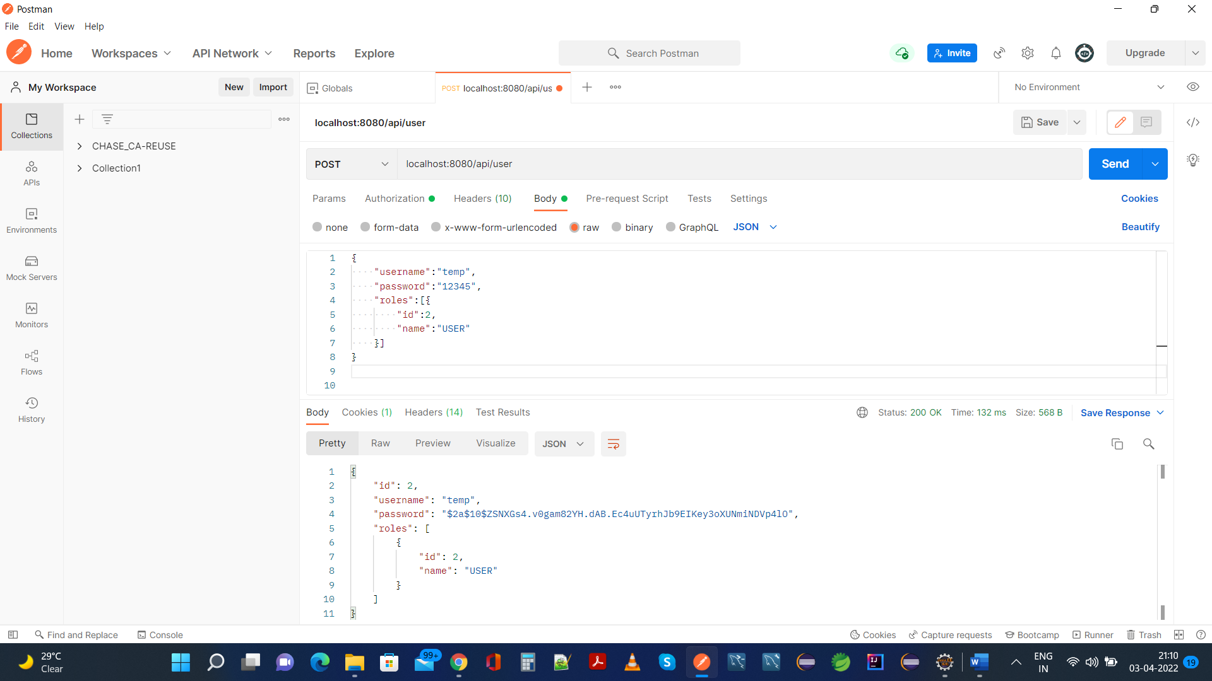

**Same is added In H2 Database:**

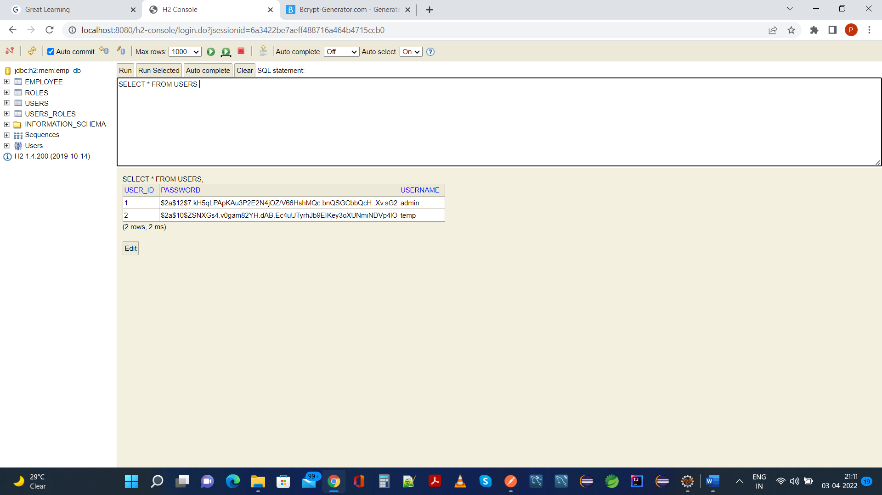

1. **Now Your application should be able to add employees data in the db if and only if the authenticated user is** **ADMIN**-

**Postman:**

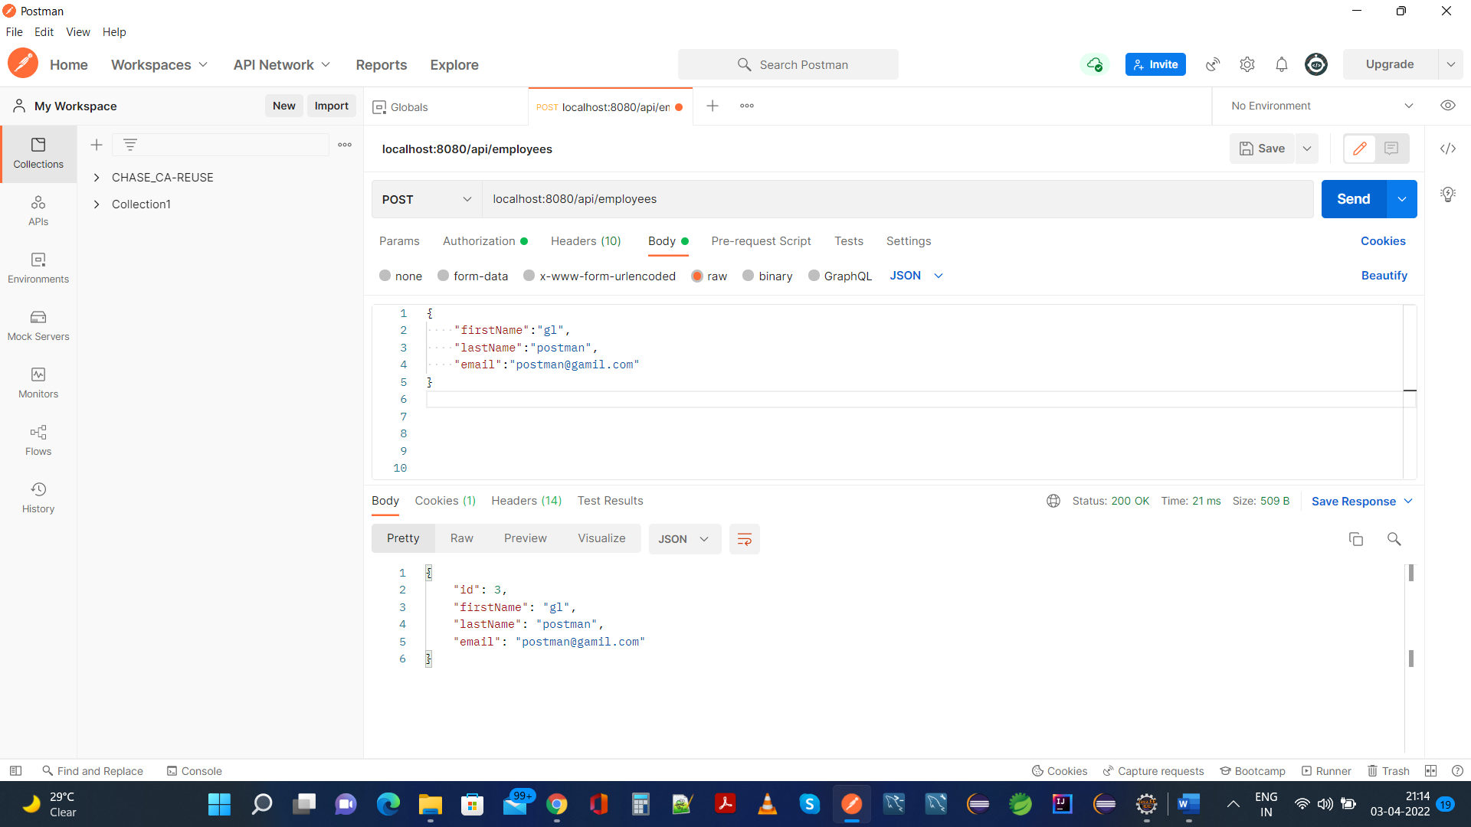

**Same is added in H2 Database:**

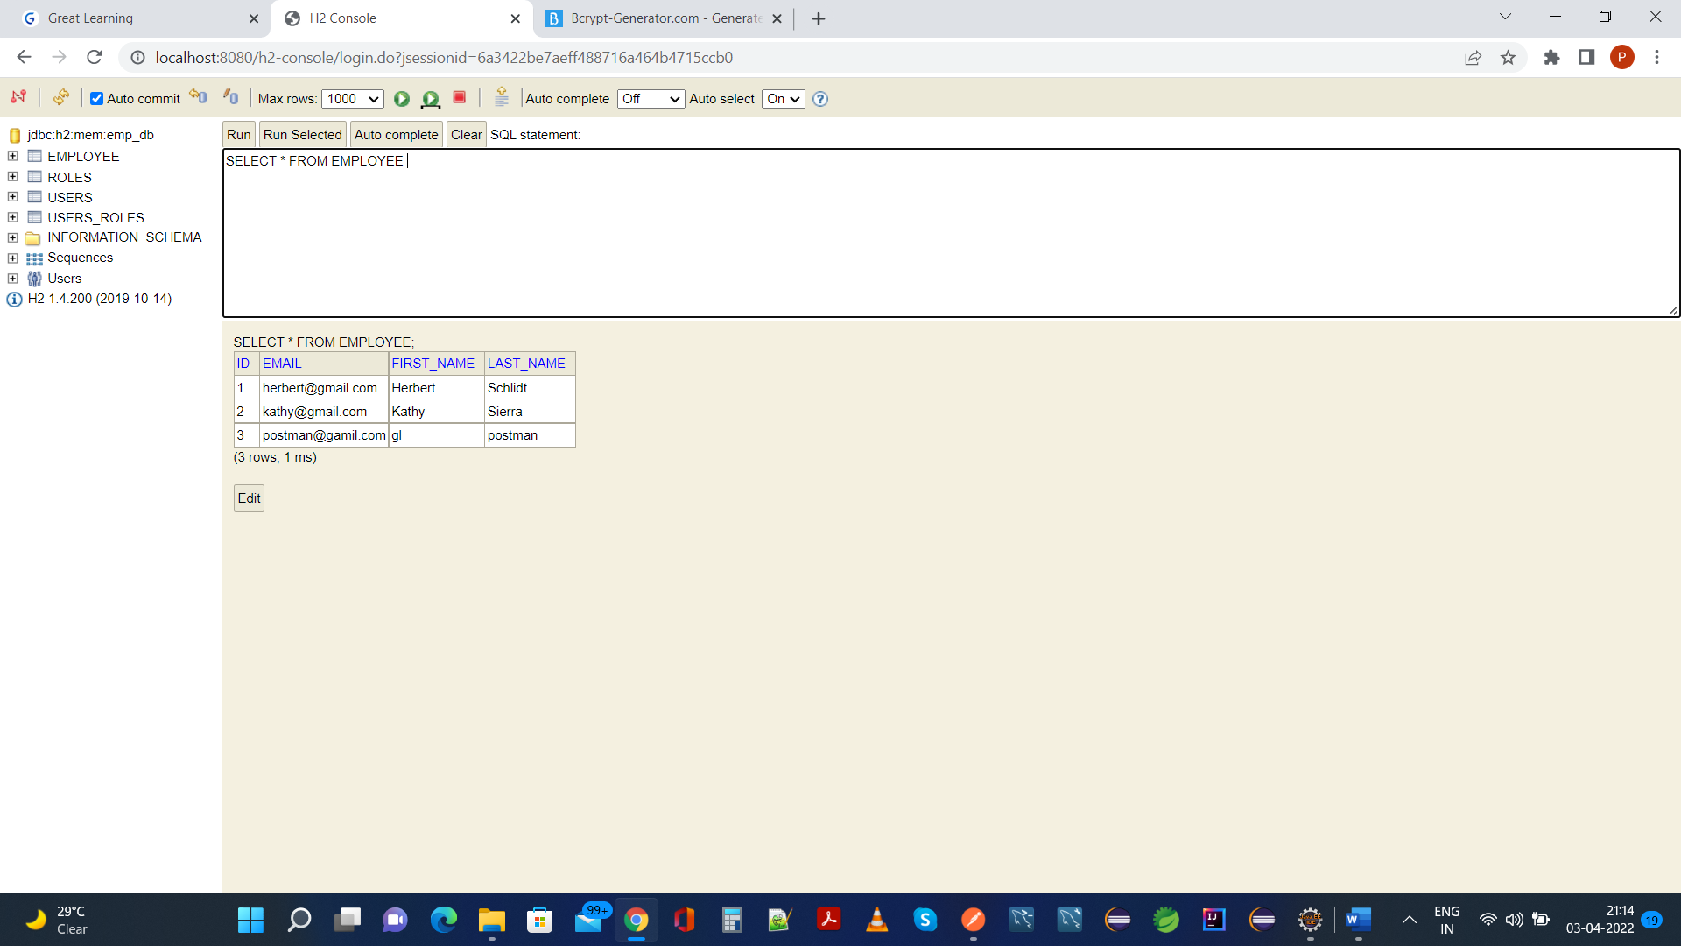

5. **Your application should provide an endpoint to list all the employees stored in the database.**

**Postman:**

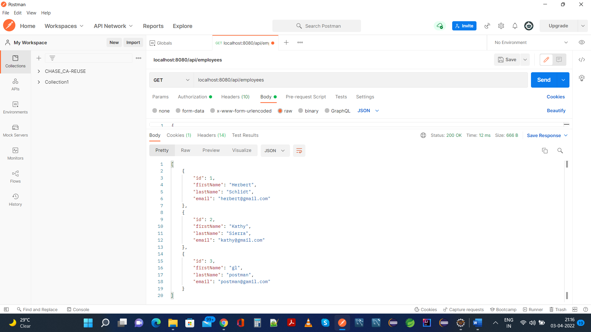

**Same as in H2 Database:**

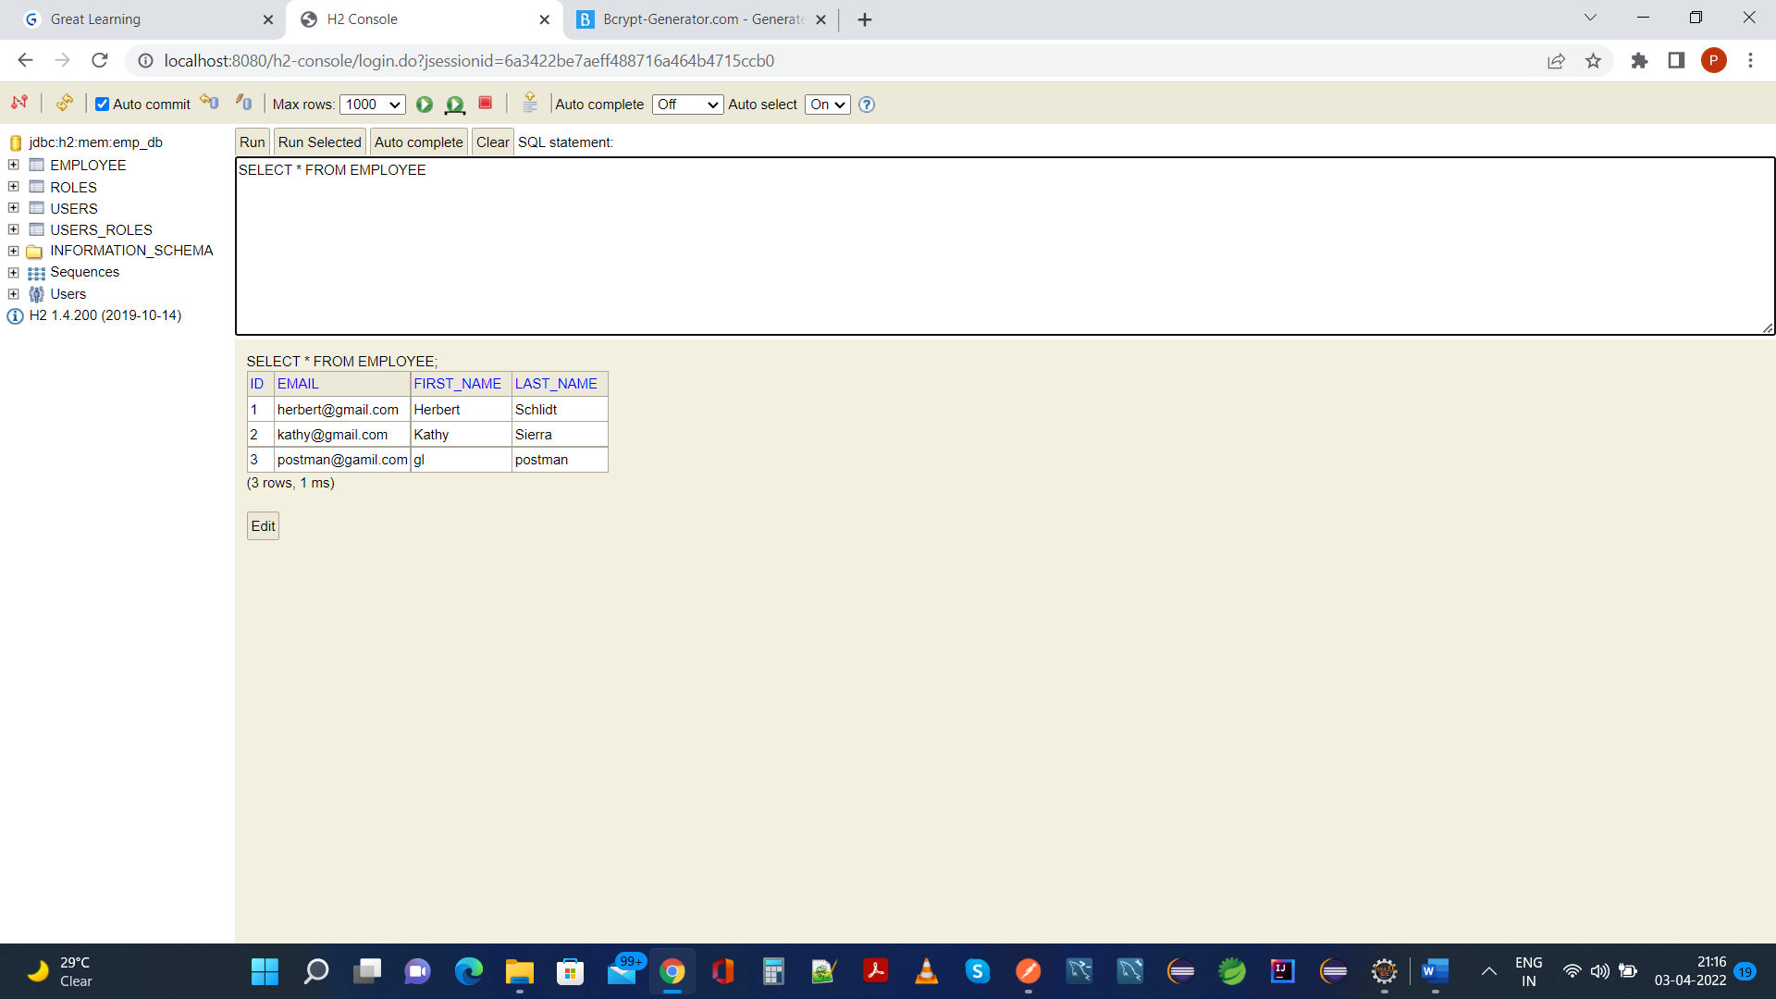

**6. Your application should provide endpoint to fetch or get an employee record specifically based on the id of that employee-**

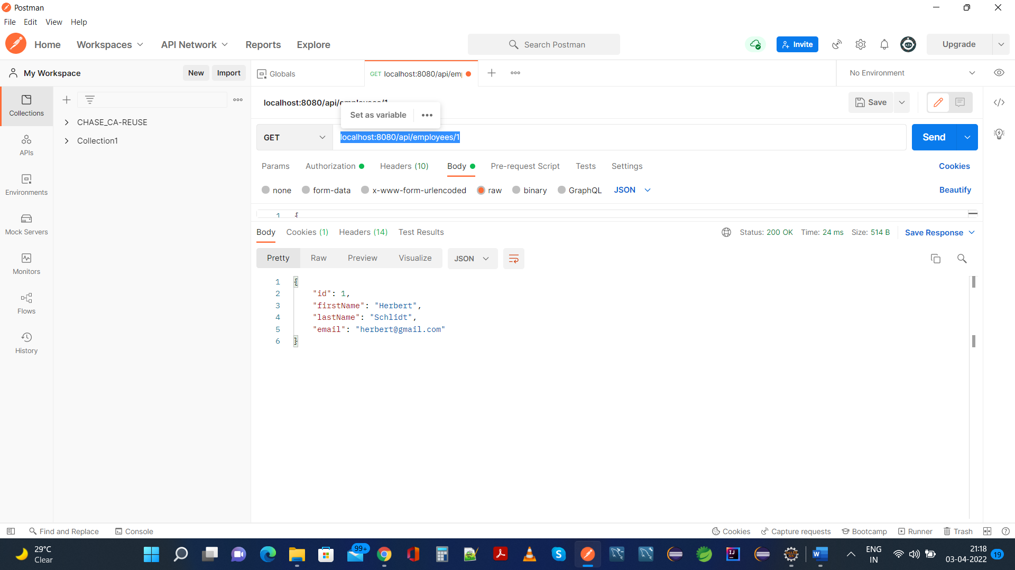

**Same Data In H2 Database:**

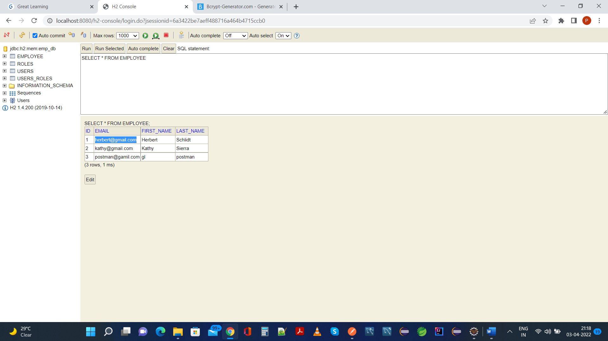

**7.** **Your application should provide an endpoint to update an existing employee record with the given updated json object**.

**Created an Employee here in Postman:**

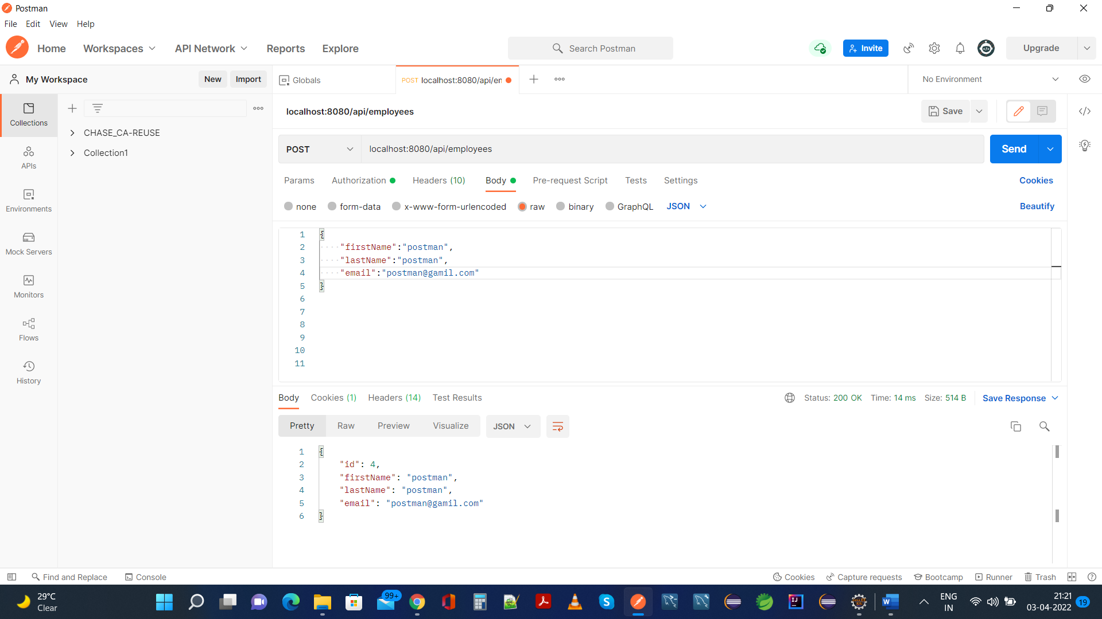

**Same is present in H2 Database:**

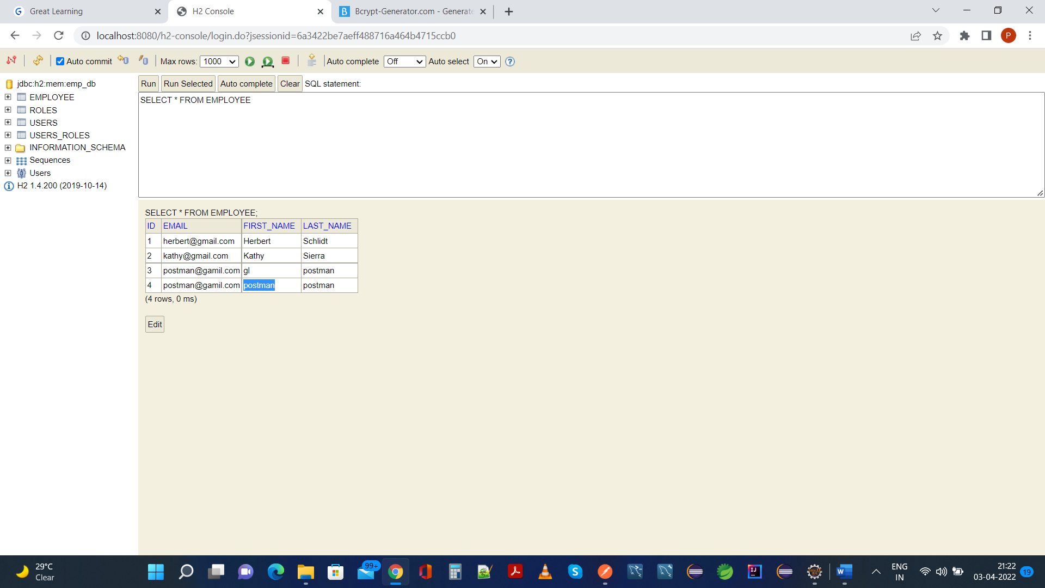

**Now Admin will update its email from gamil.com into gmail.com:**

**Postman:**

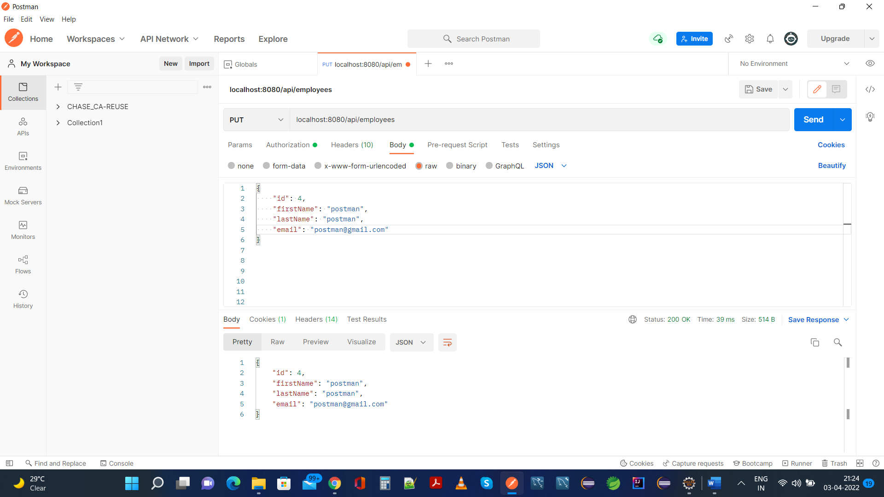

**Same is reflected in H2 Database:**

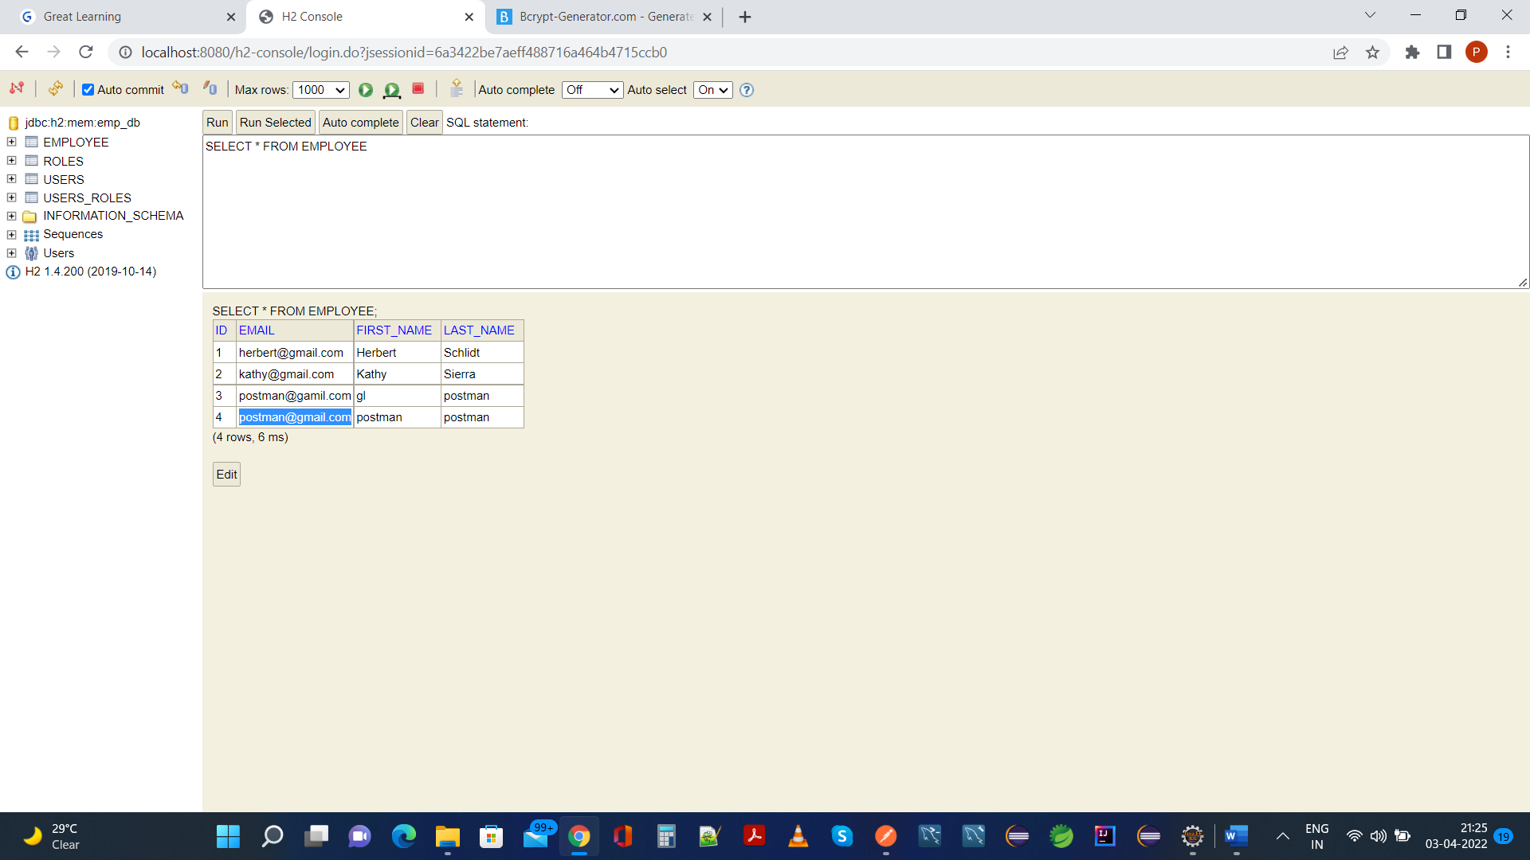

8. **Your application should also provide an endpoint to delete an existing employee record based on the id of the employee-**

**Postman:**

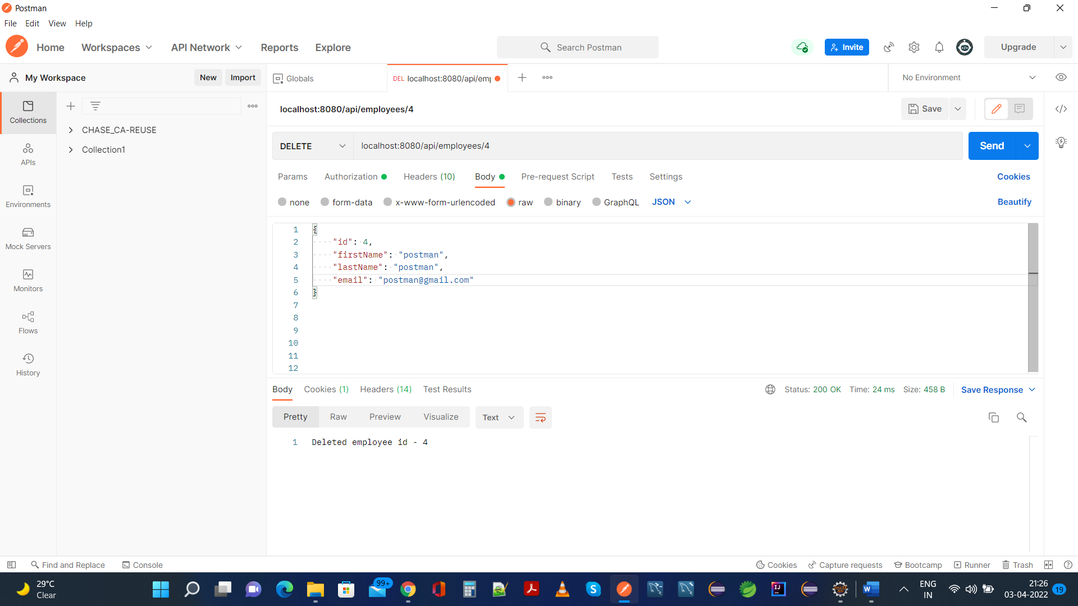

**Same is reflected in H2 Database where Employee Id 4 is not present:**

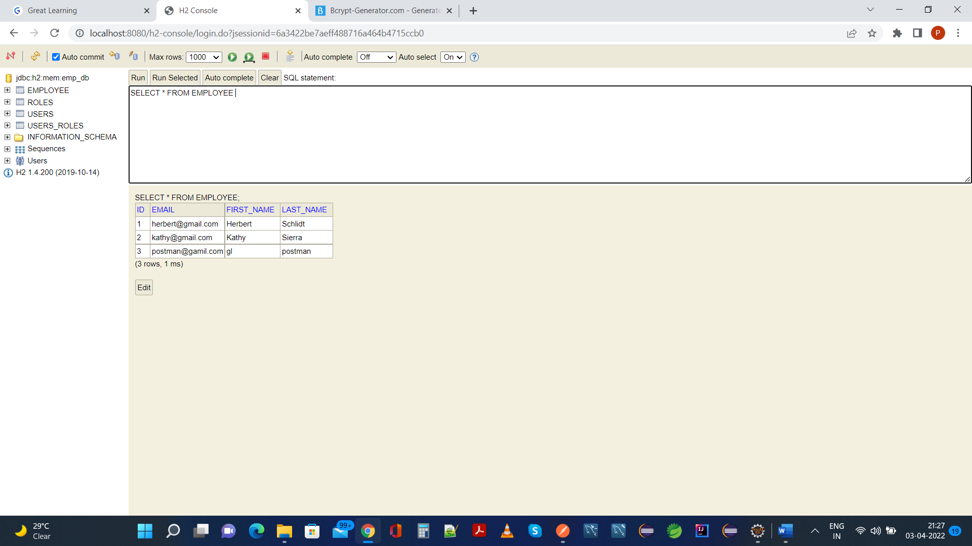

**9. Your application should provide an endpoint to fetch an employee by his/her first name and if found more than one record then list them all**-

**Another Employee With Same First Name As “gl” is created for demonstrating multiple Employees having same First Name:**

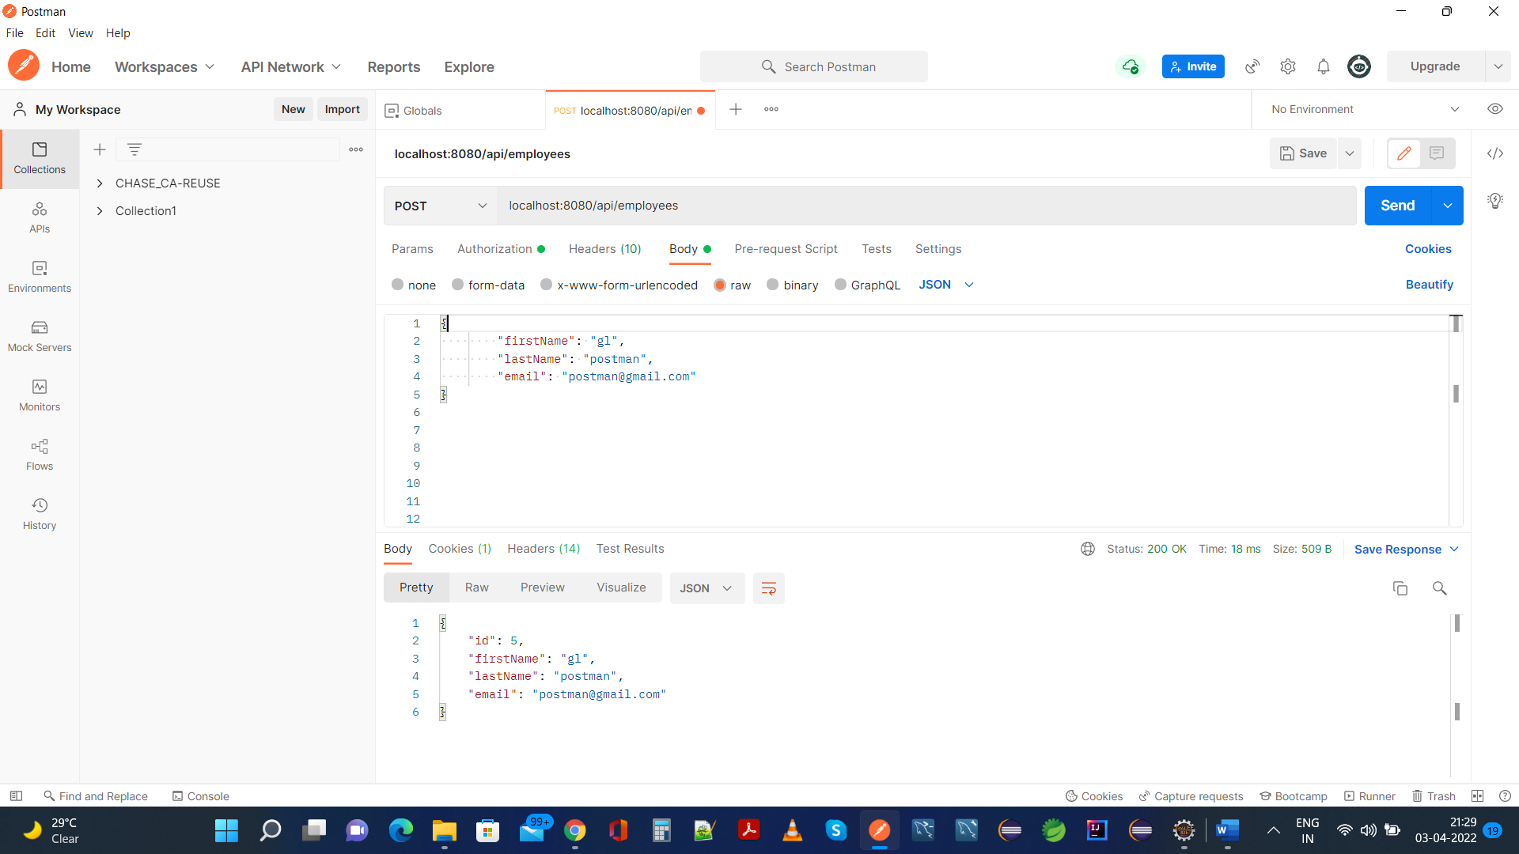

**Same Is Present In H2 Database:**

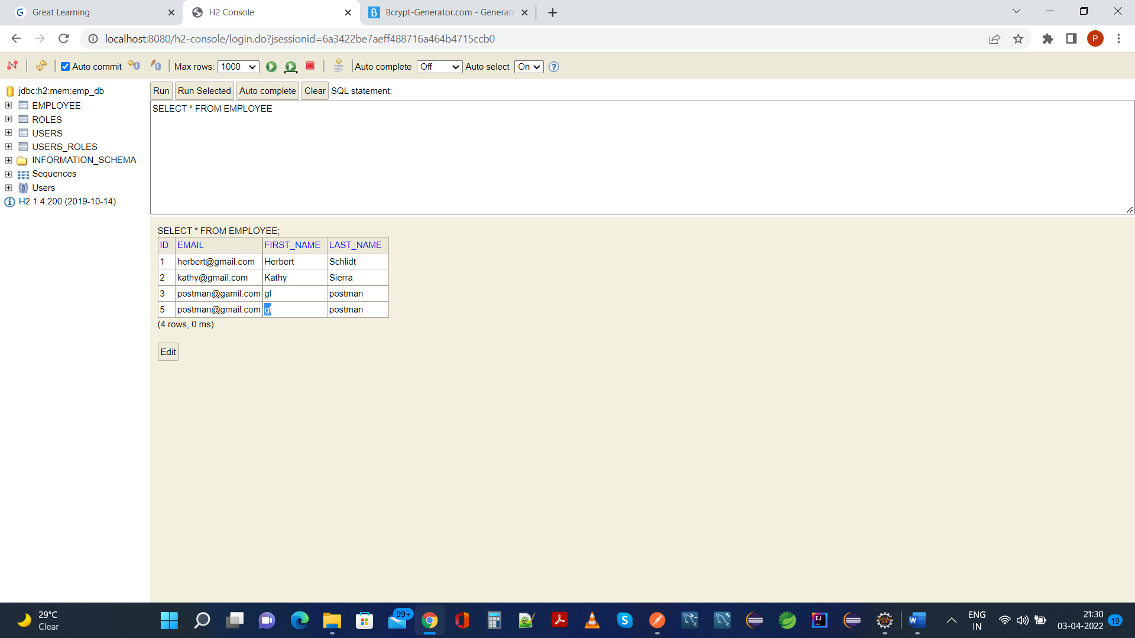

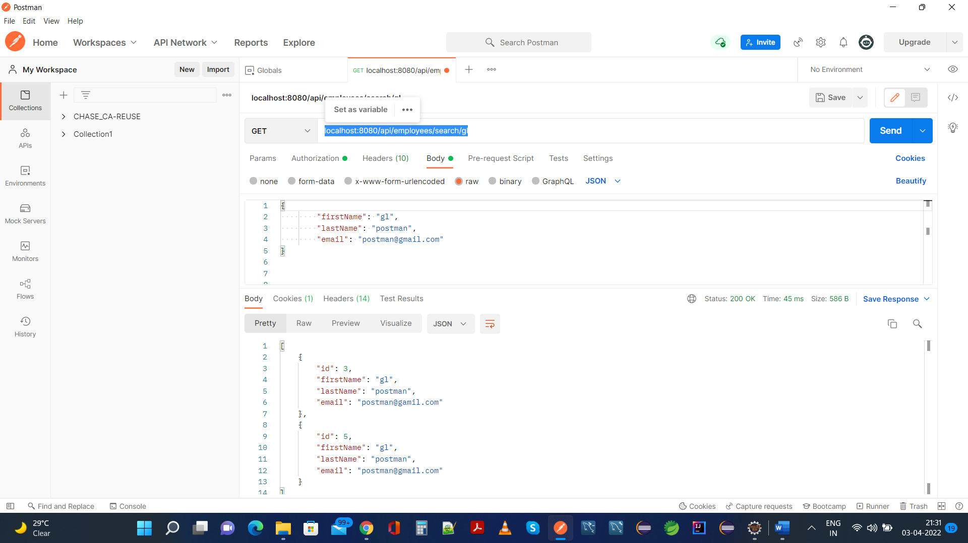

**10. Your application should be able to list all employee records sorted on their first name in either ascending order or descending order** .

**Postman:**

**Sort Employees In Ascending Order:**

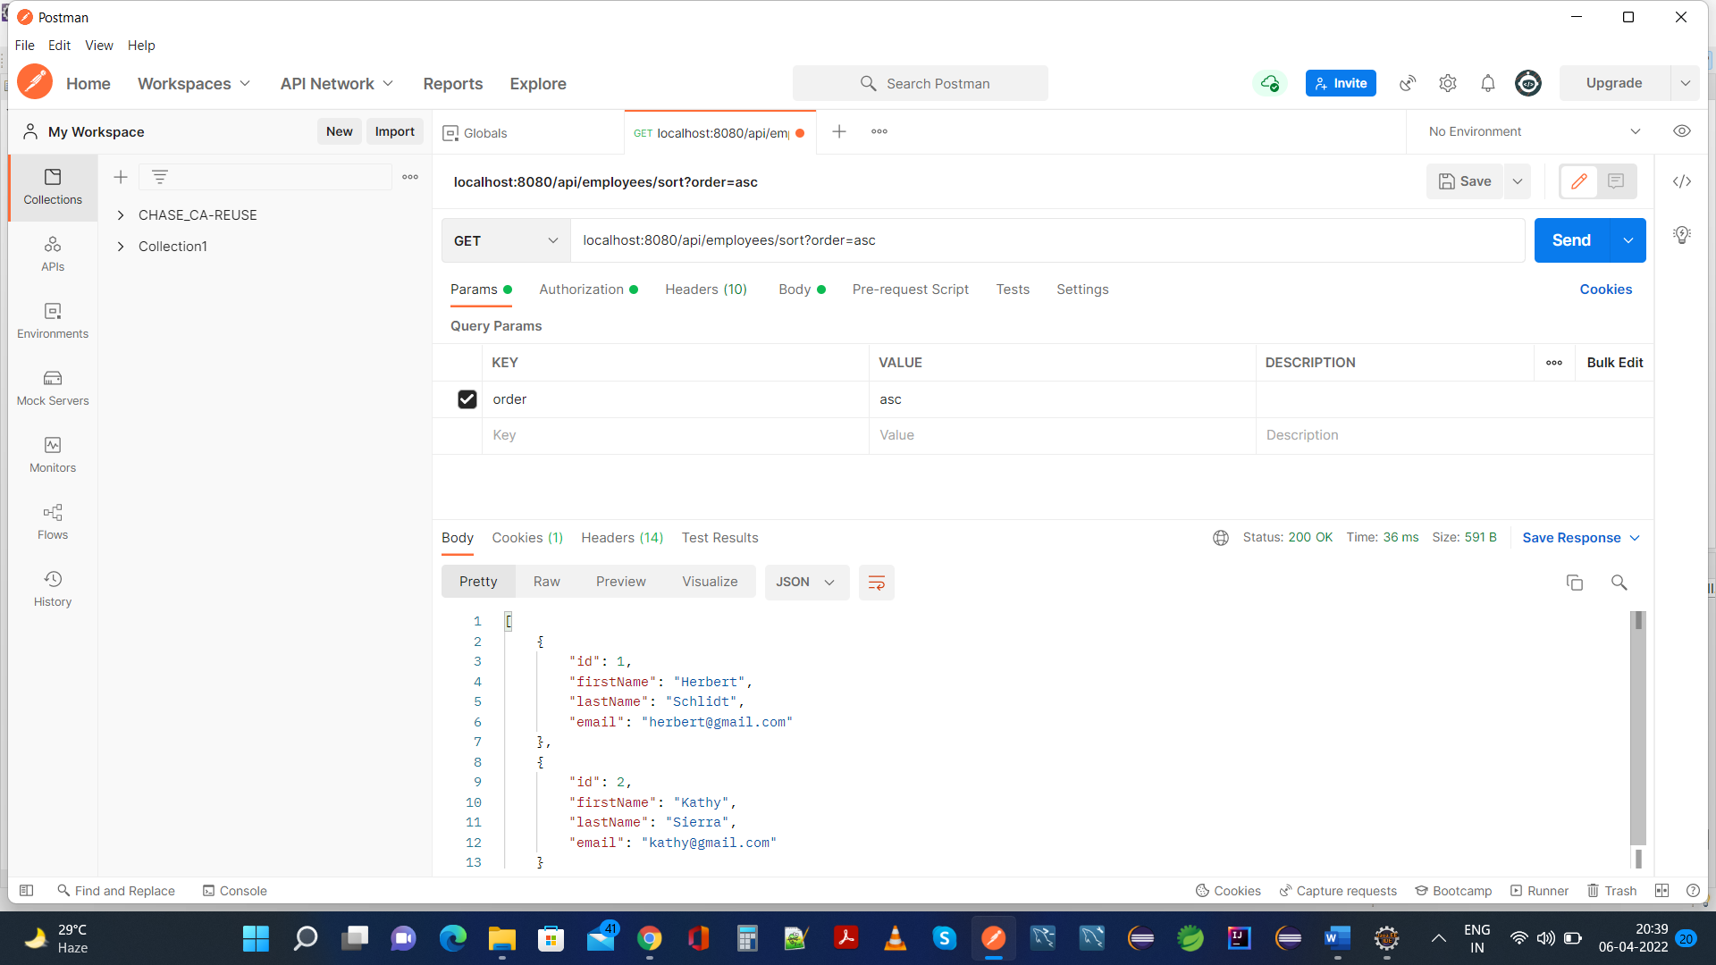

**Sort Employees In Descending Order:**

**Postman:**

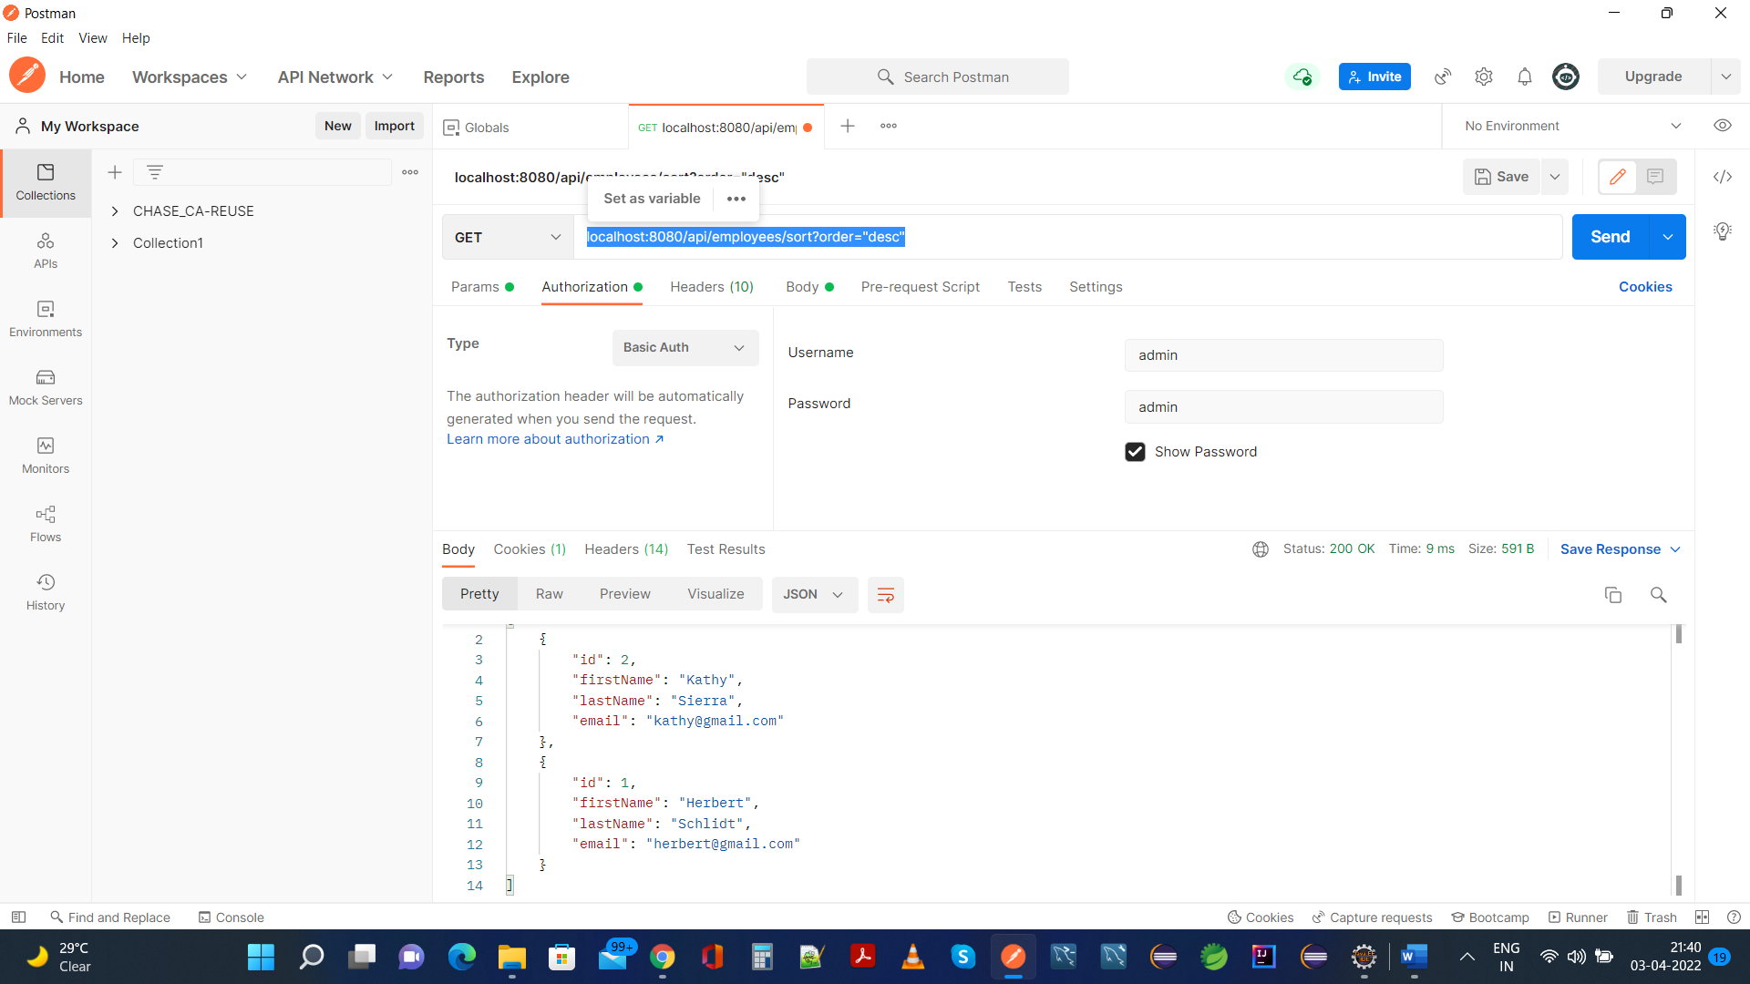

**Application Console For Reference:**

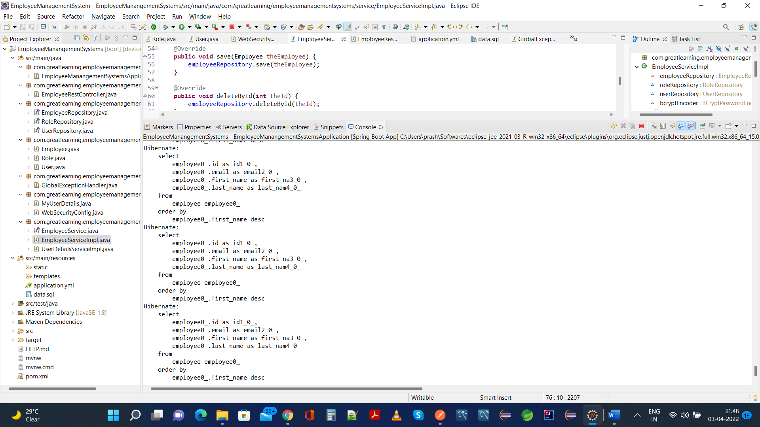

**As a User That Is Not Admin:**

**Current H2 Database Schema And Tables:**

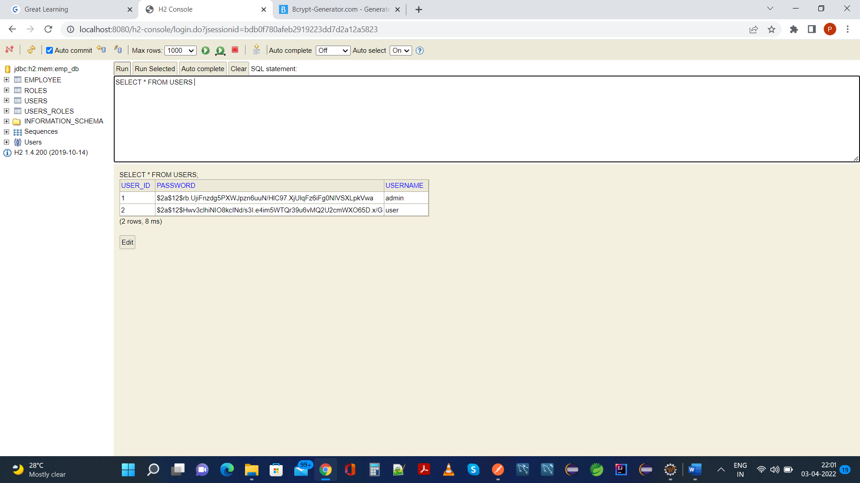

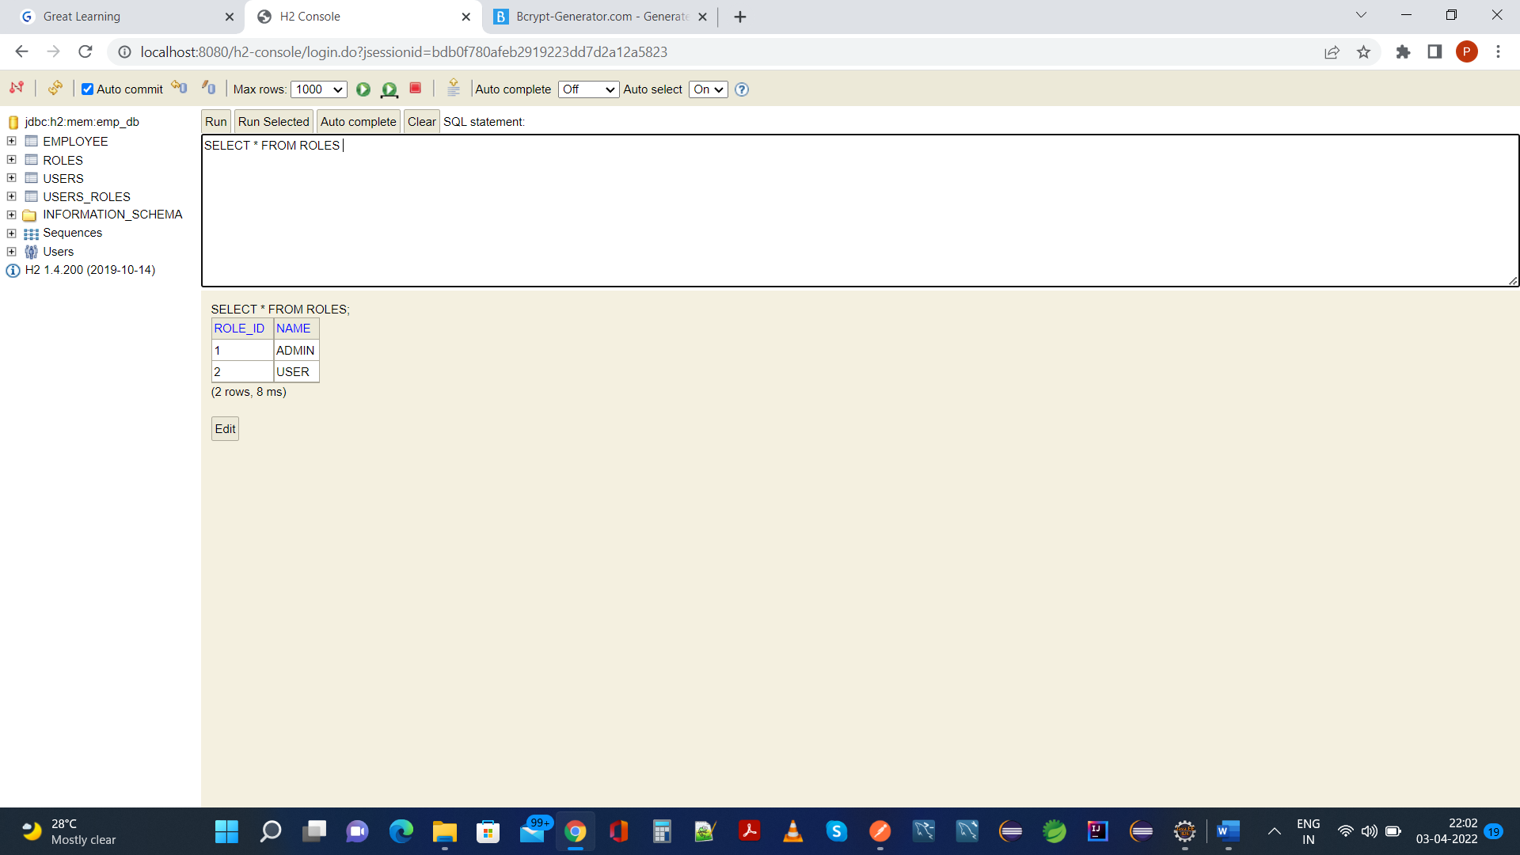

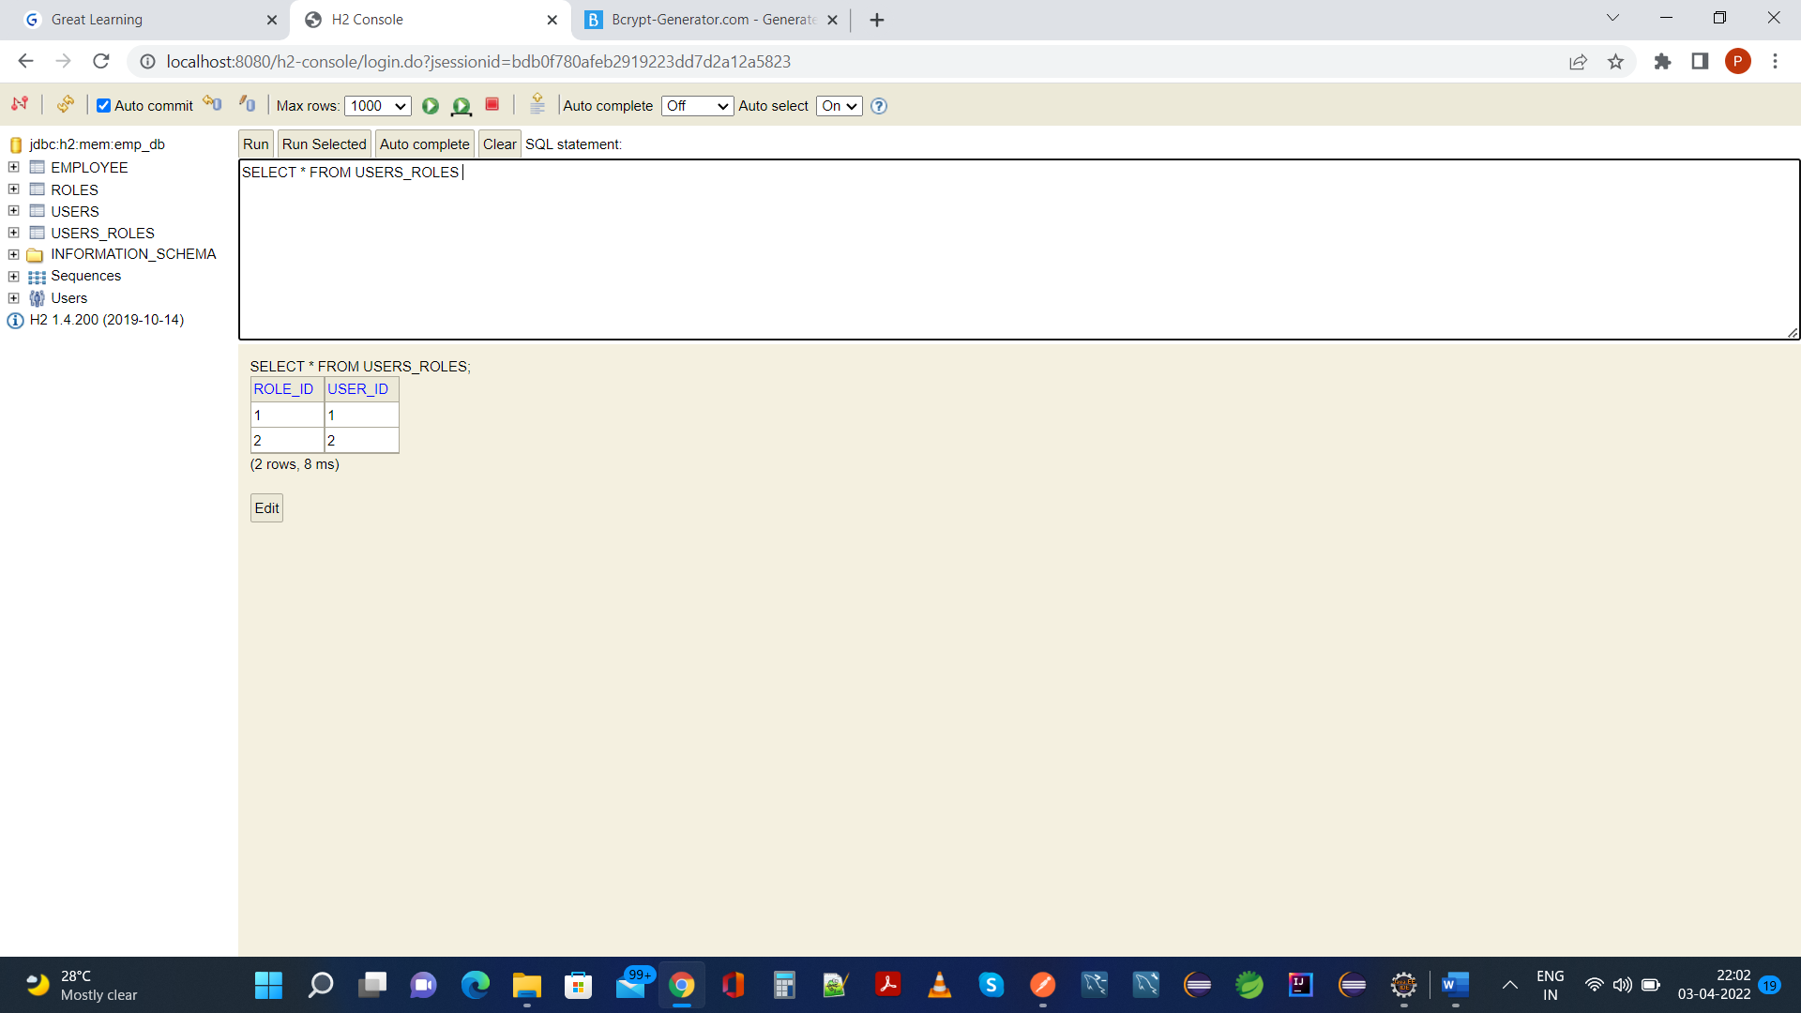

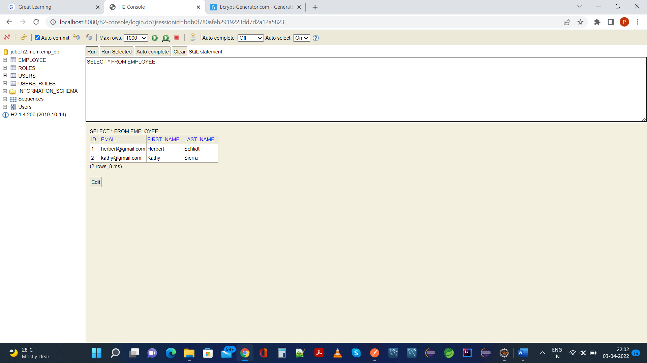

**1.Your application should be able to add roles in the database dynamically in the db.**

**As User That Is Not Admin:**

**Login As User:**

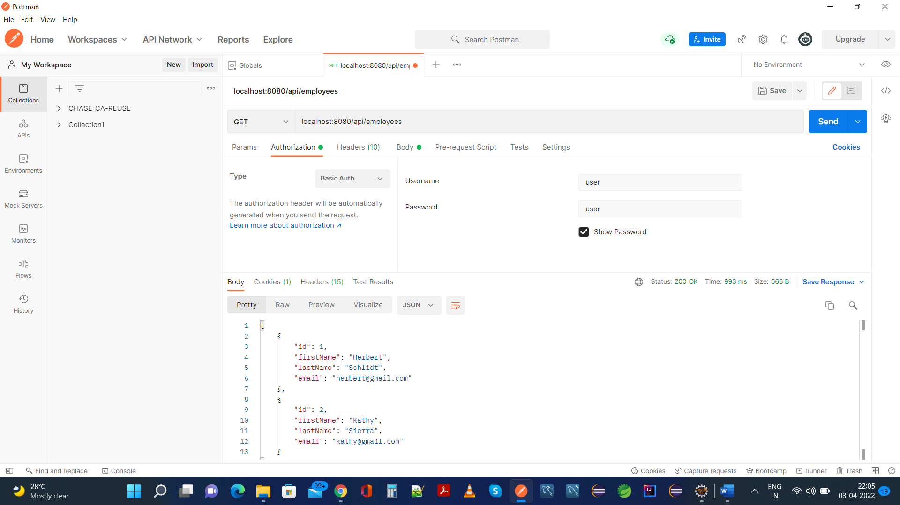

**Create a Role As Users from the current USER Role:**

**Postman:**

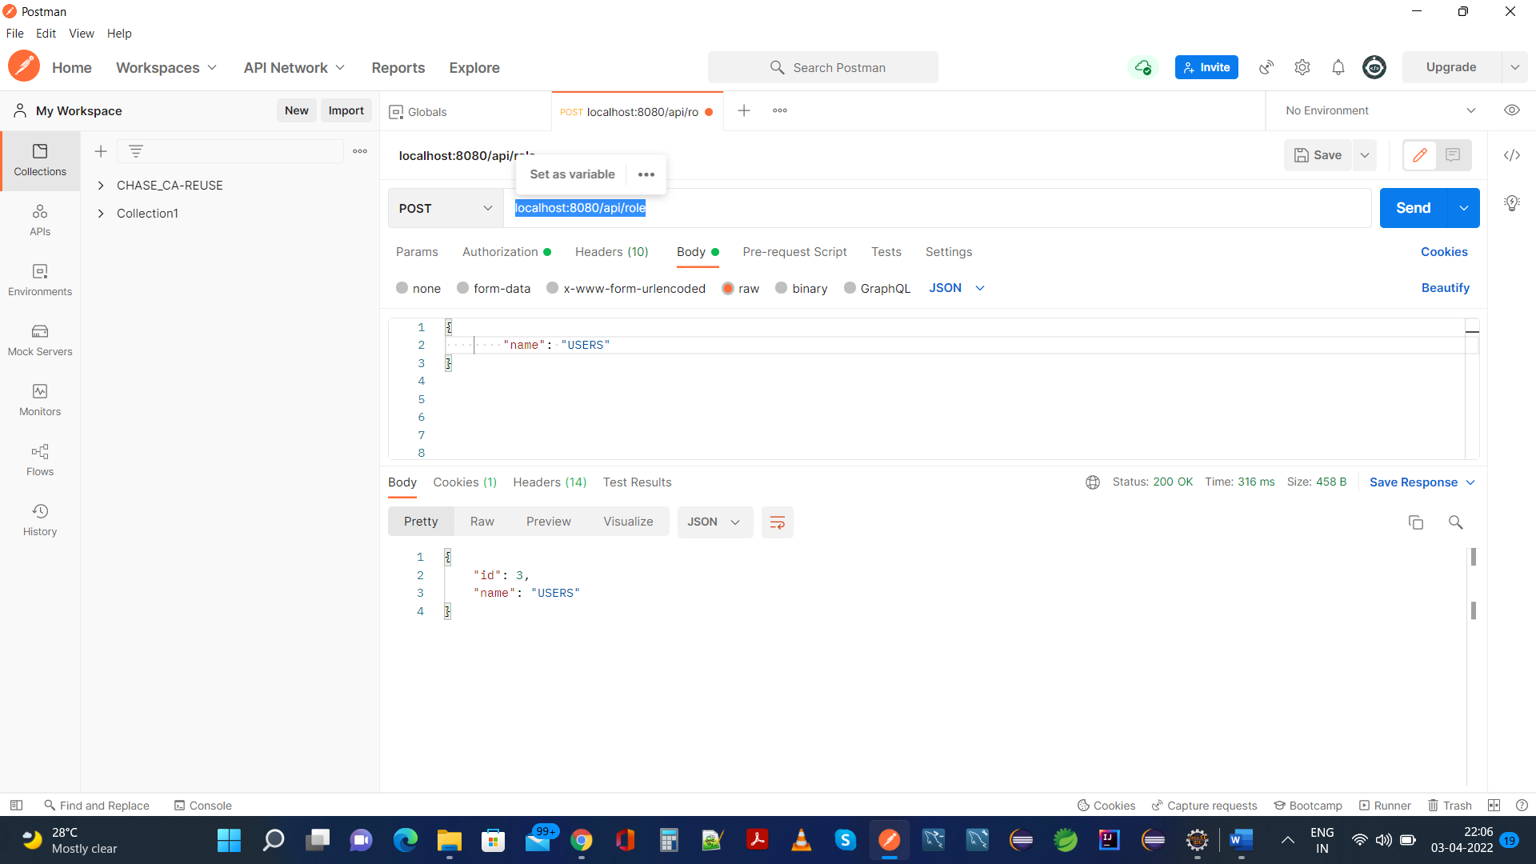

**Same is reflected In H2 Database:**

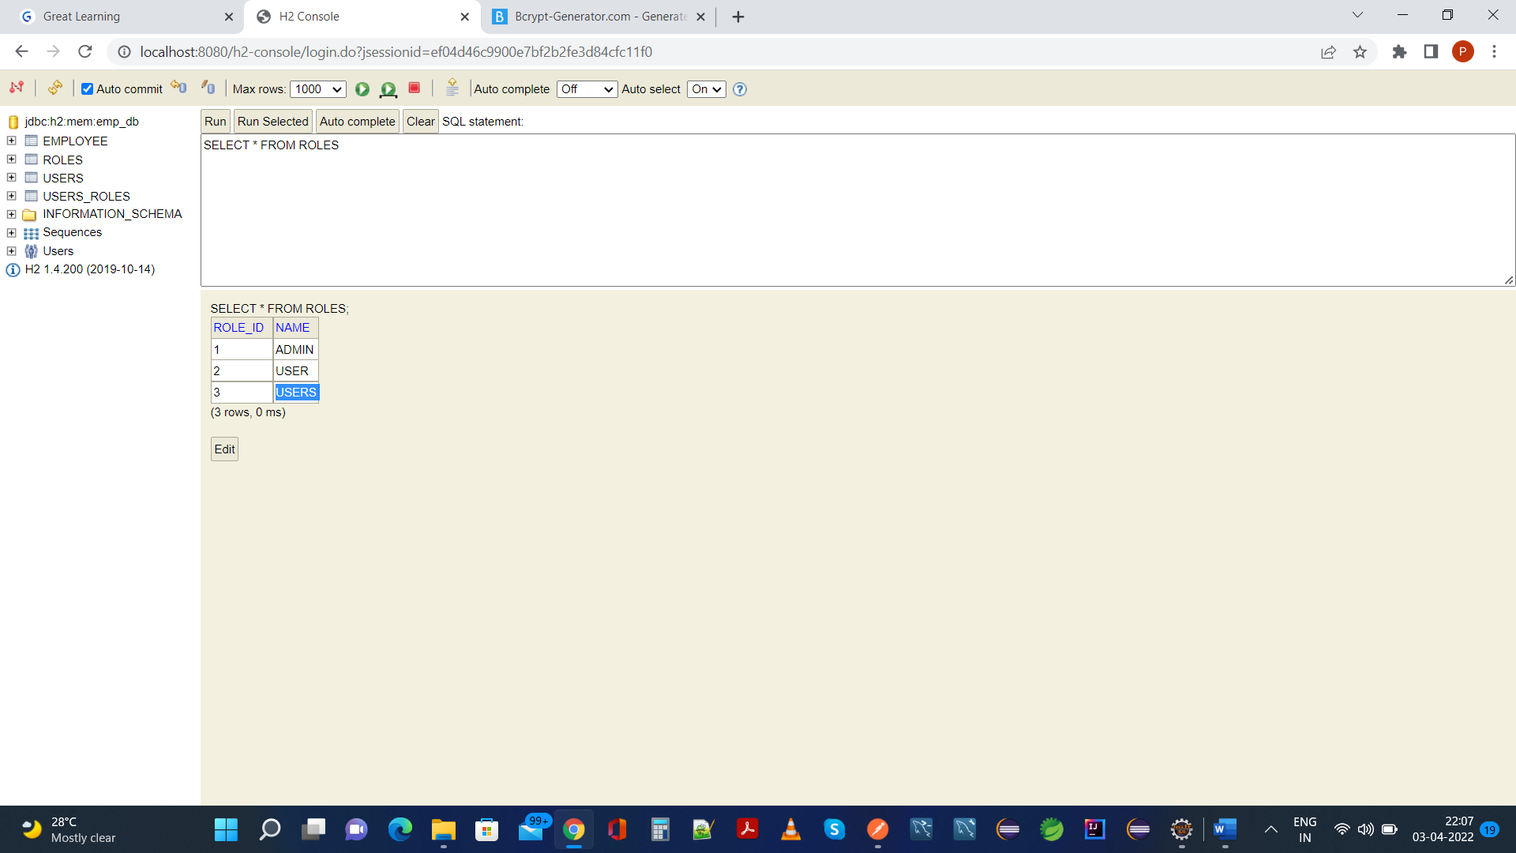

**2. Your application should be able to add Users in the db which can be used for authentication purposes.**

**Postman:**

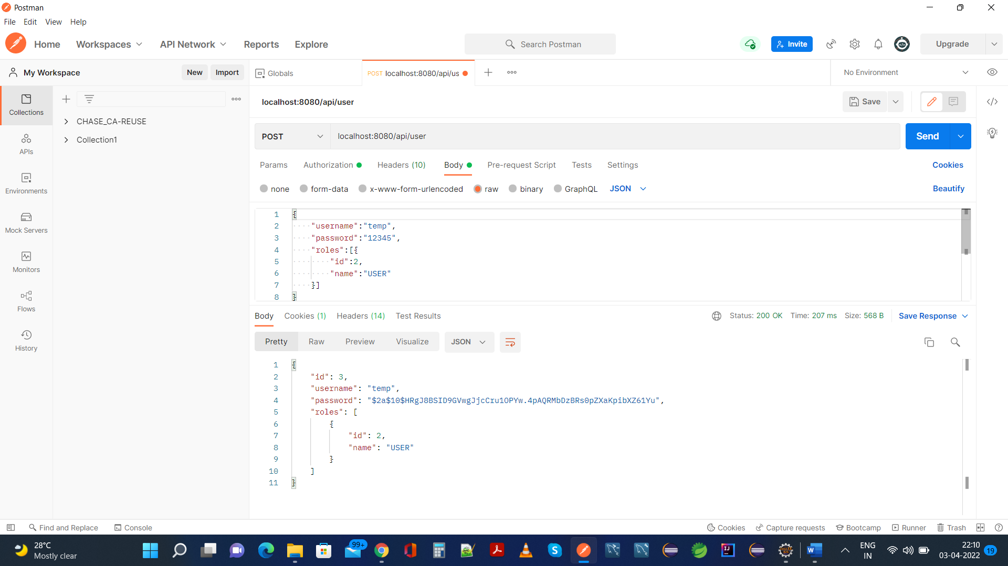

**Same Is Reflected In H2 Database:**

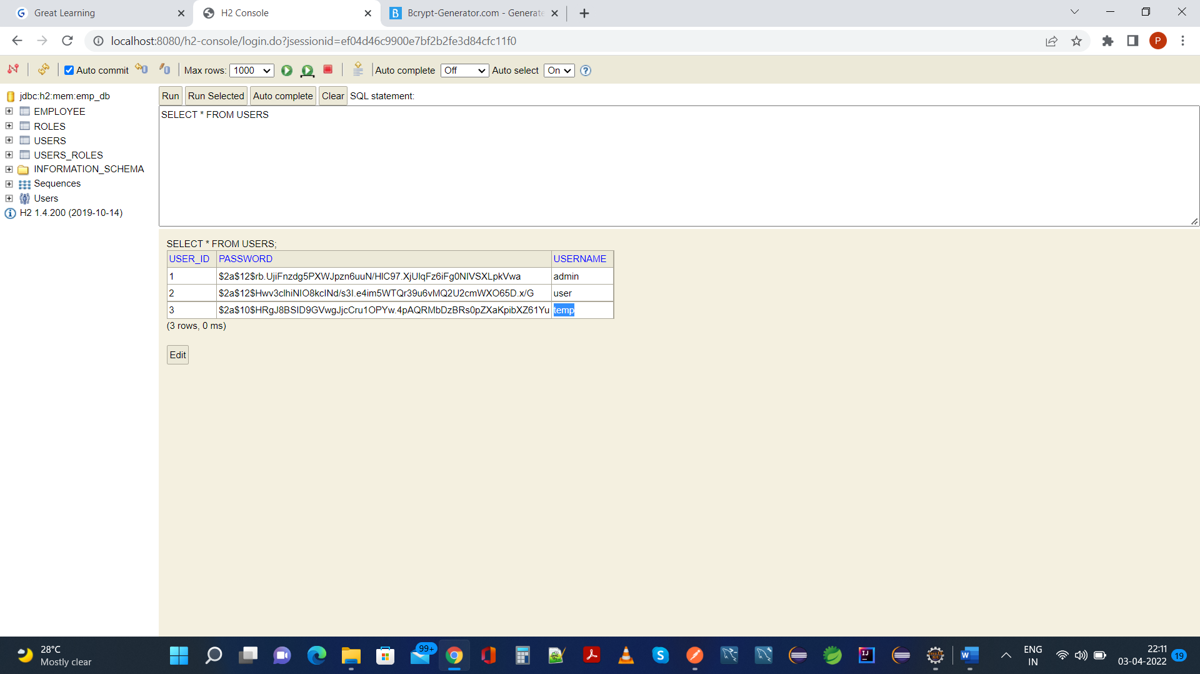

**3. Now Your application should be able to add employees data in the db if and only if the authenticated user is** **ADMIN**-

NOTE: Since we are logged in as USER Authority/Role, so it is expected here that we cannot add any Employee, as according to Problem Statement, only ADMIN Authority/Role Can Create Employee:

**Postman:**

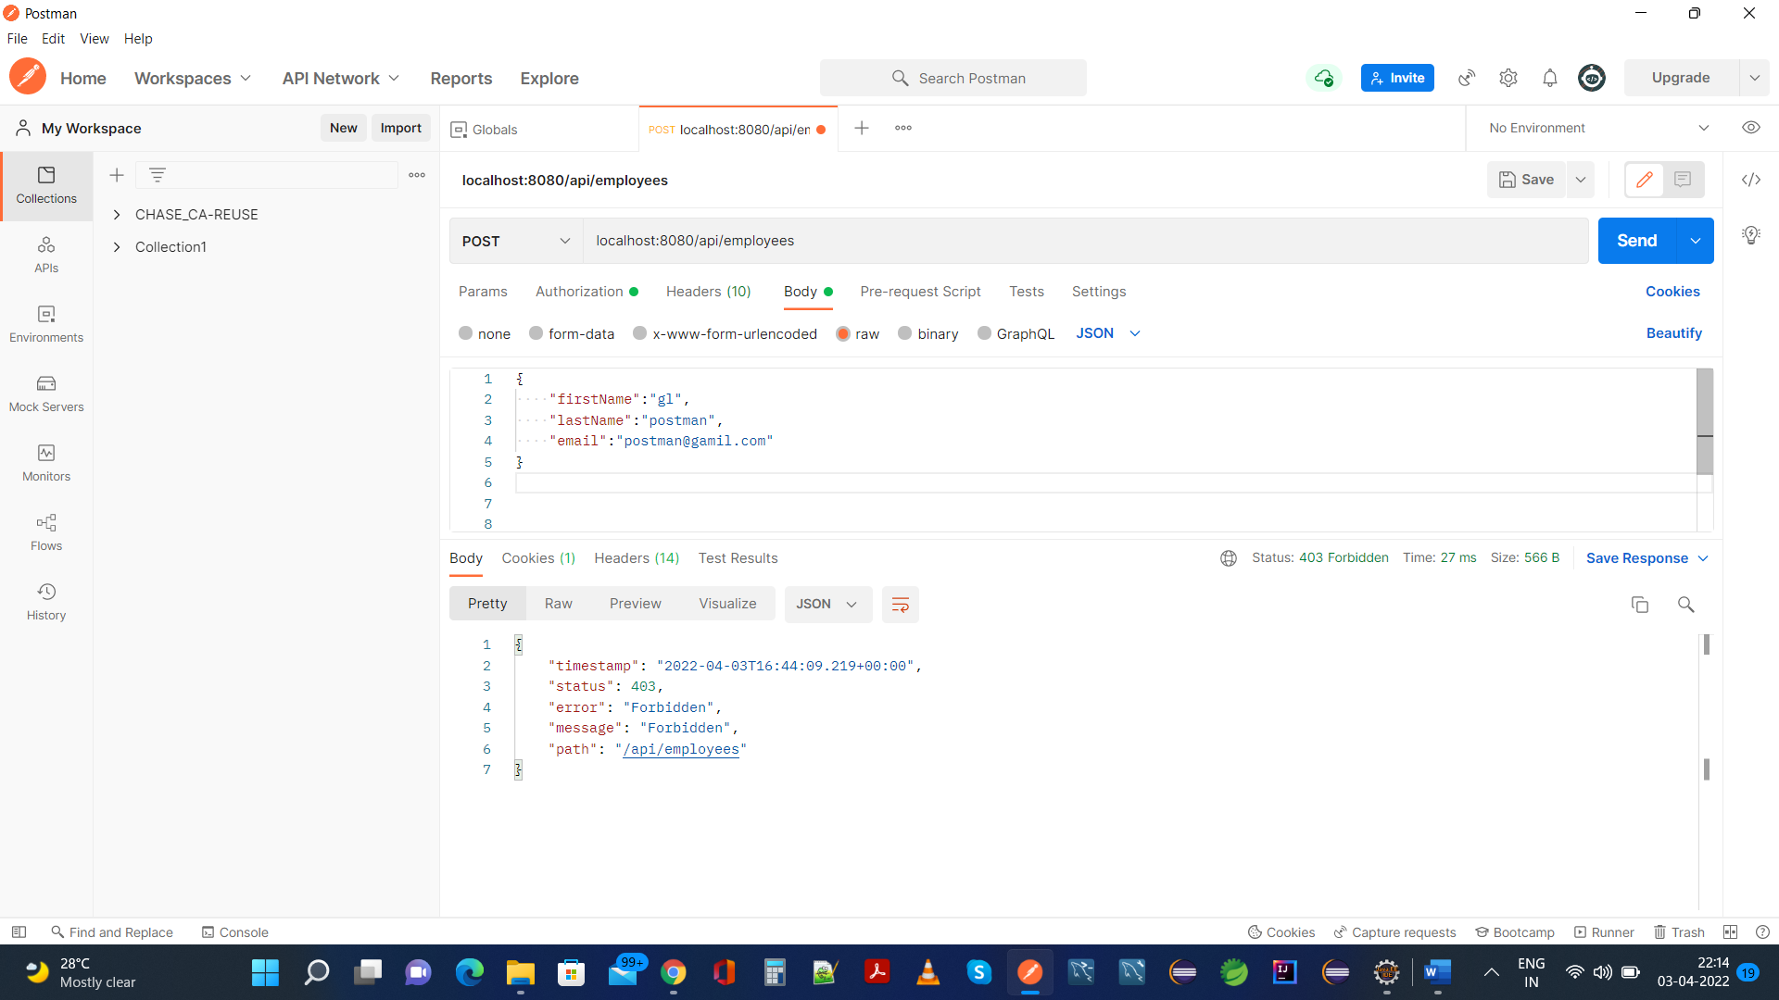

**As Expected USER Role Or Any Other Role Except ADMIN, cannot add Employee,**

**So, In H2 Database, this Employee Should Not Be Present:**

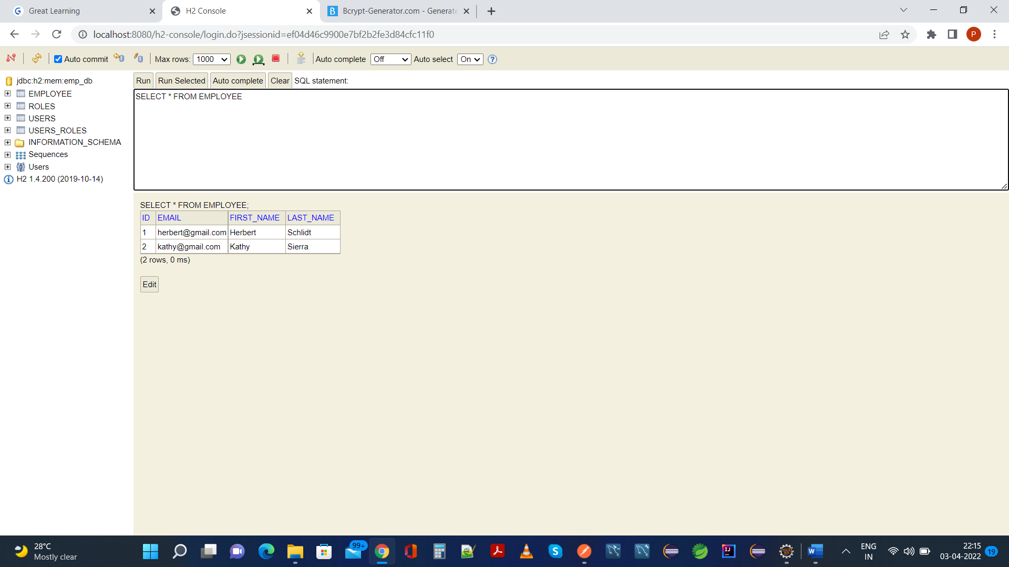

1. **Your application should provide an endpoint to list all the employees stored in the database.**

**Postman:**

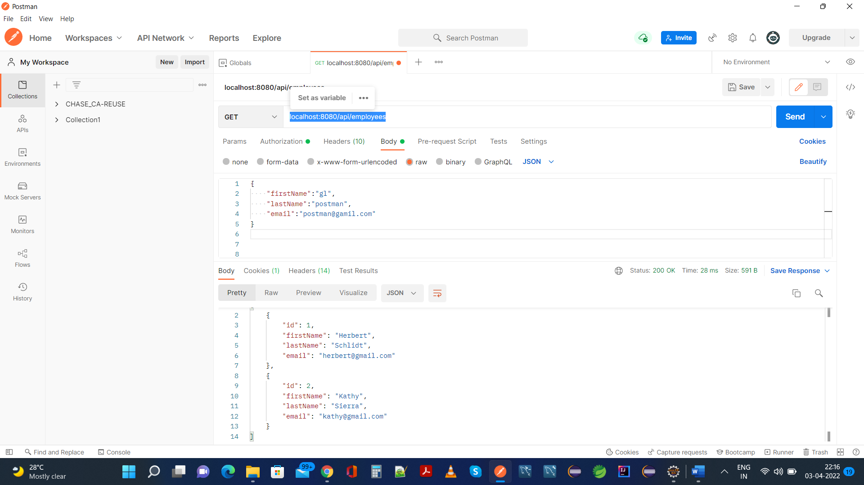

**Same As H2 Database:**

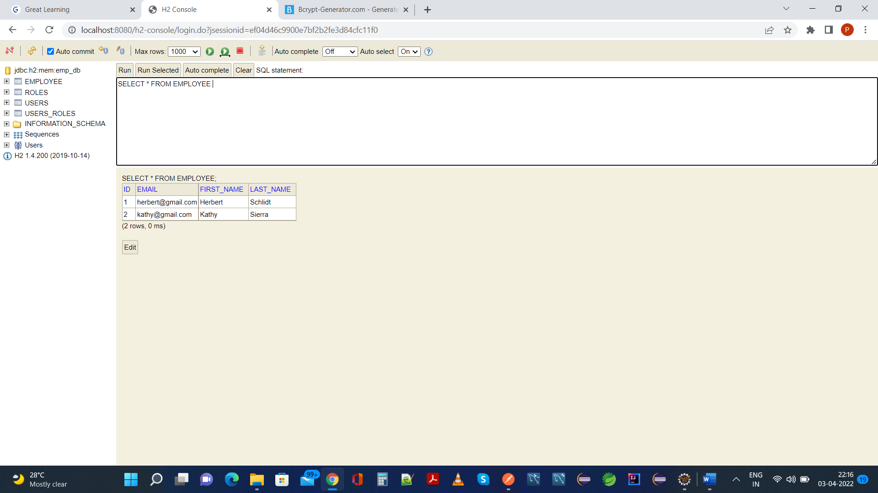

1. **Your application should provide endpoint to fetch or get an employee record specifically based on the id of that employee-**

**Postman:**

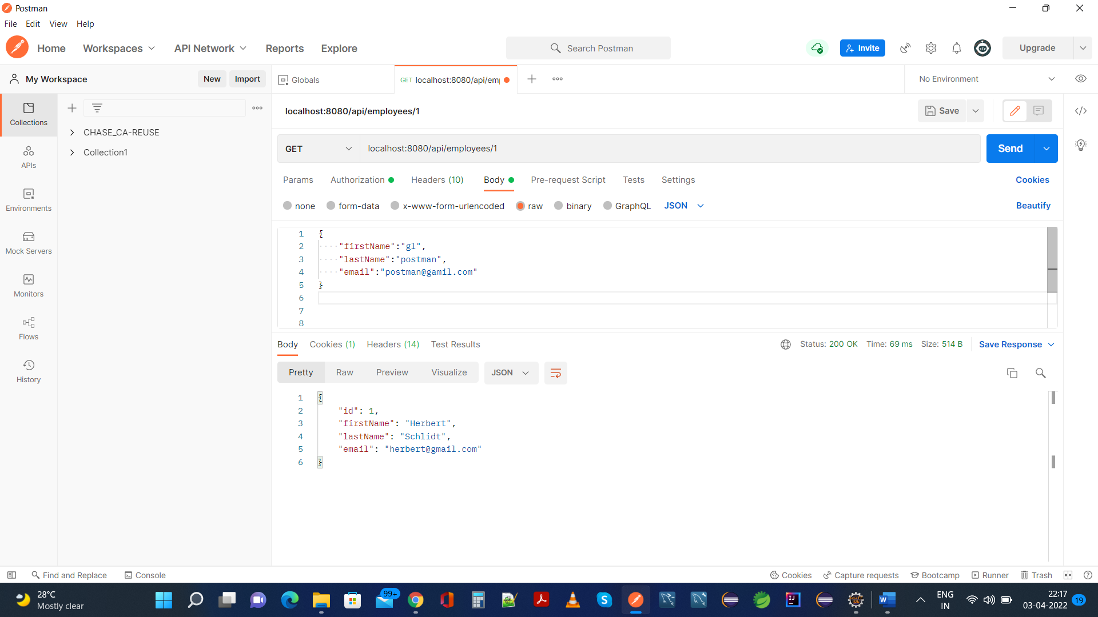

**Same as in H2 Database:**

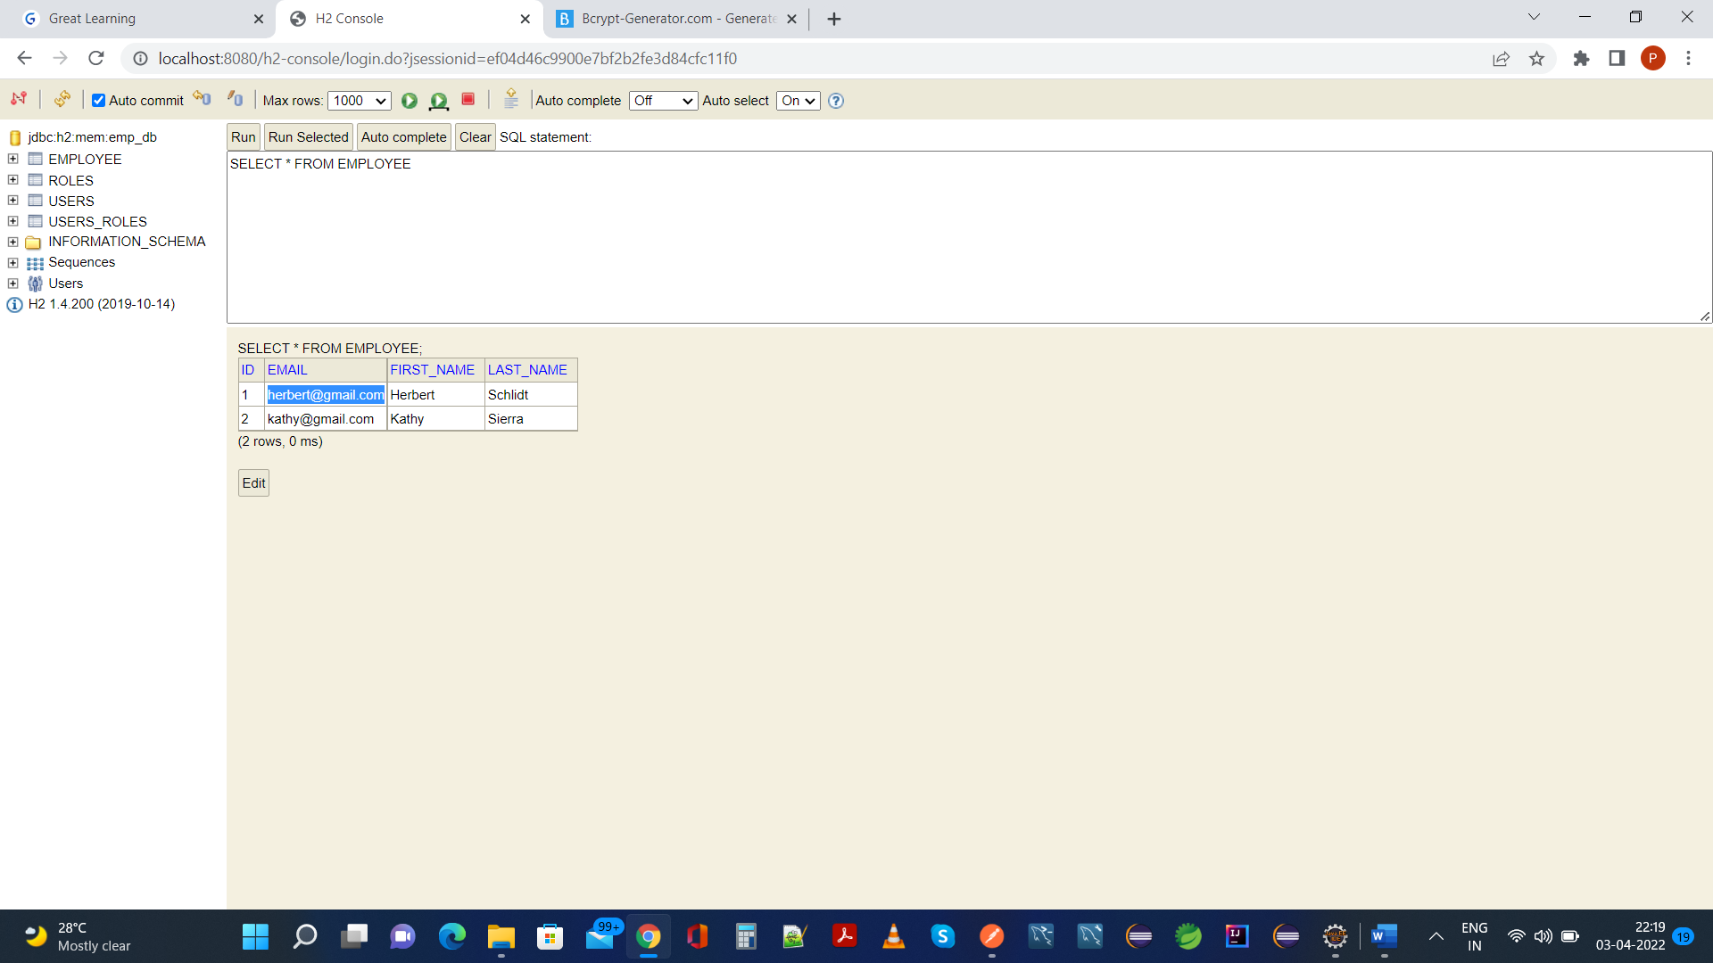

**6. Your application should provide an endpoint to update an existing employee record with the given updated json object.**

**Postman:**

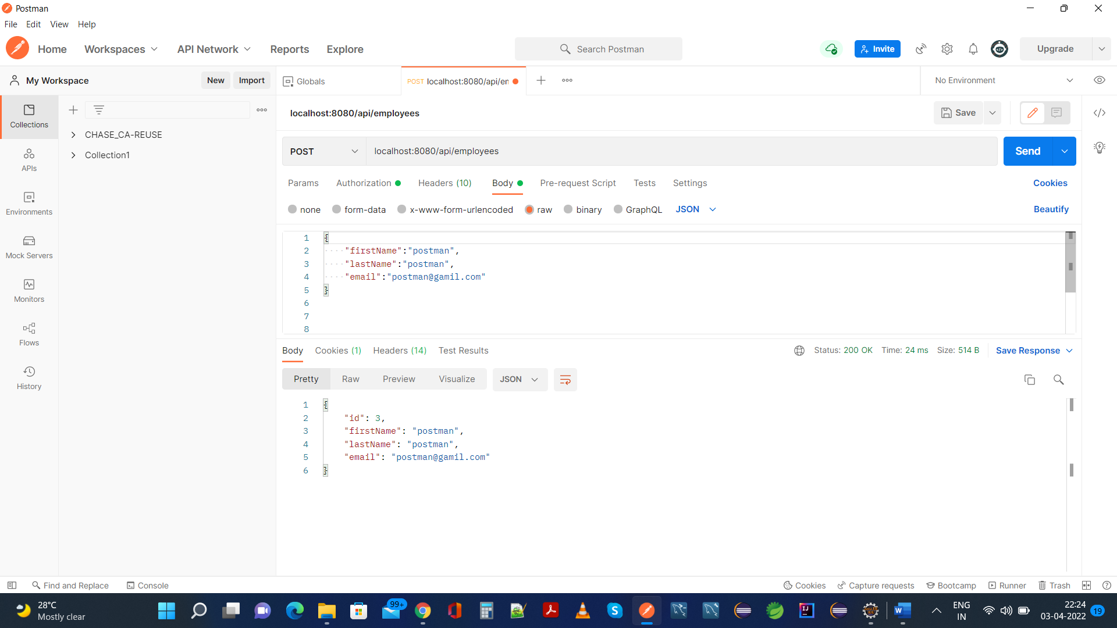

**This is updated in Email Using HttpMethod.PUT:**

**Postman:**

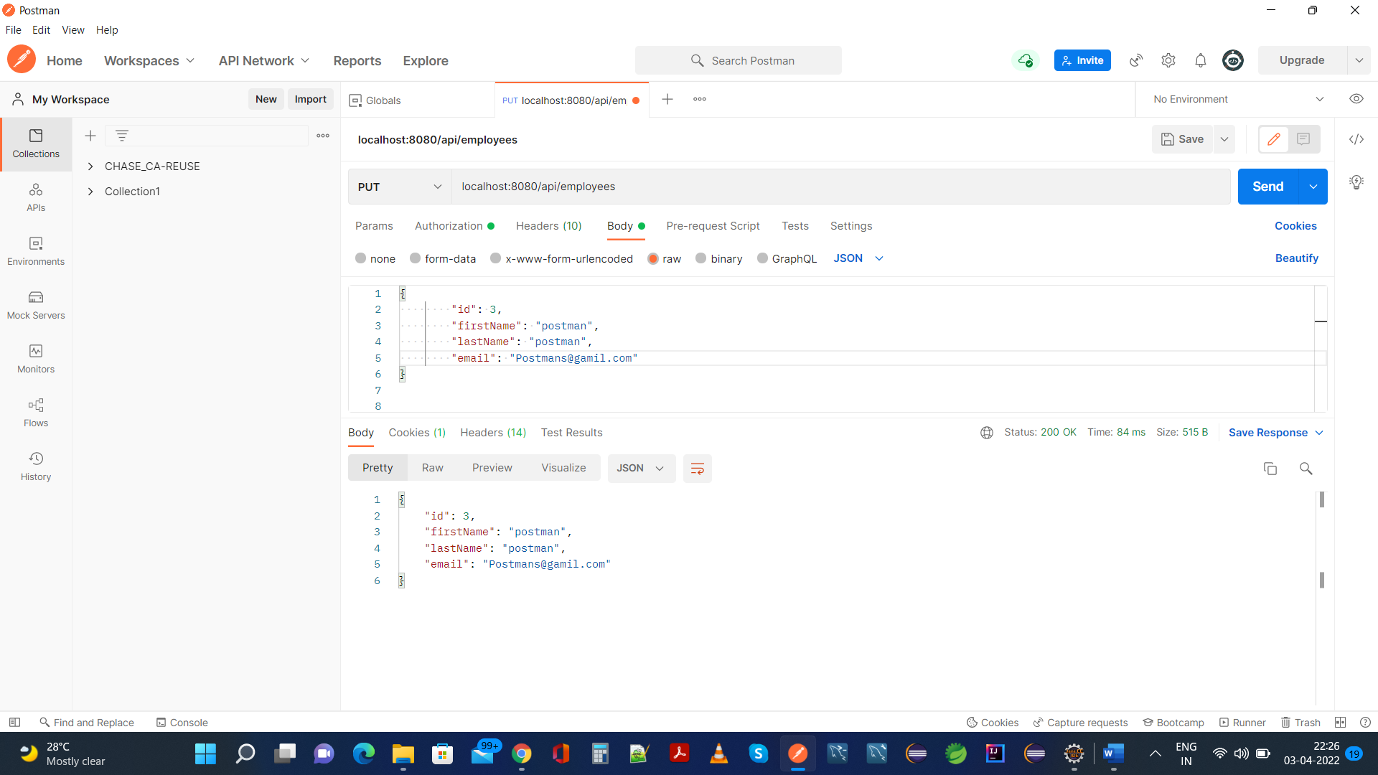

**Email Update Is Reflected In H2 Database:**

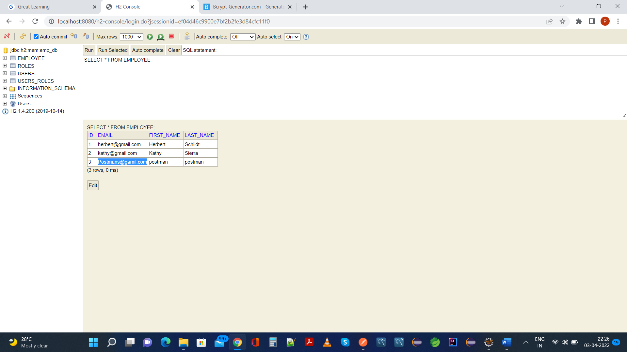

1. **Your application should also provide an endpoint to delete an existing employee record based on the id of the employee-**

**Postman: Here we will delete with Employee Id 3**

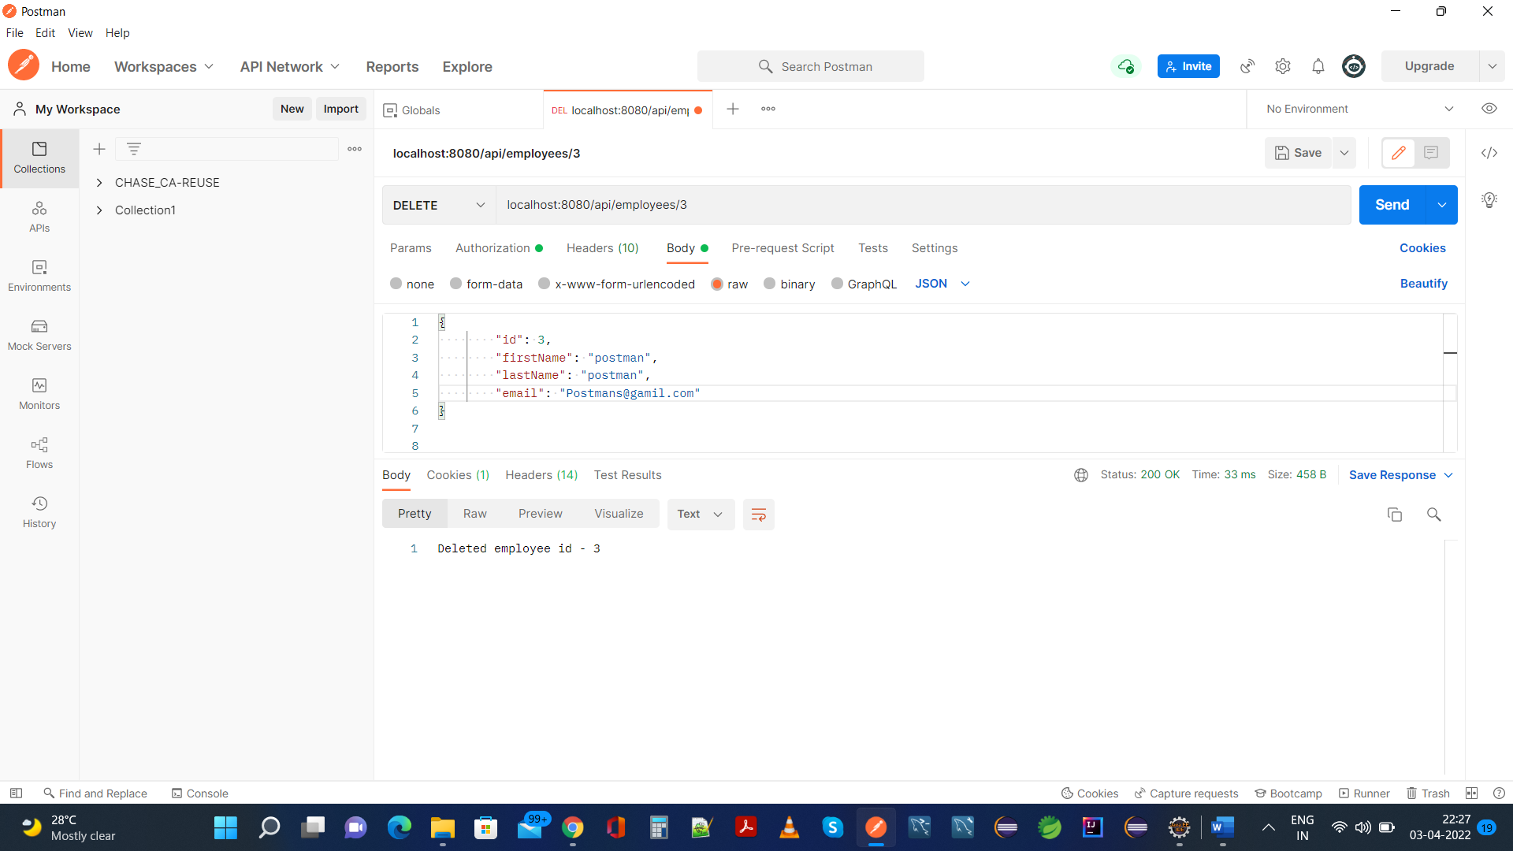

**Same Is Reflected In H2 Database:**

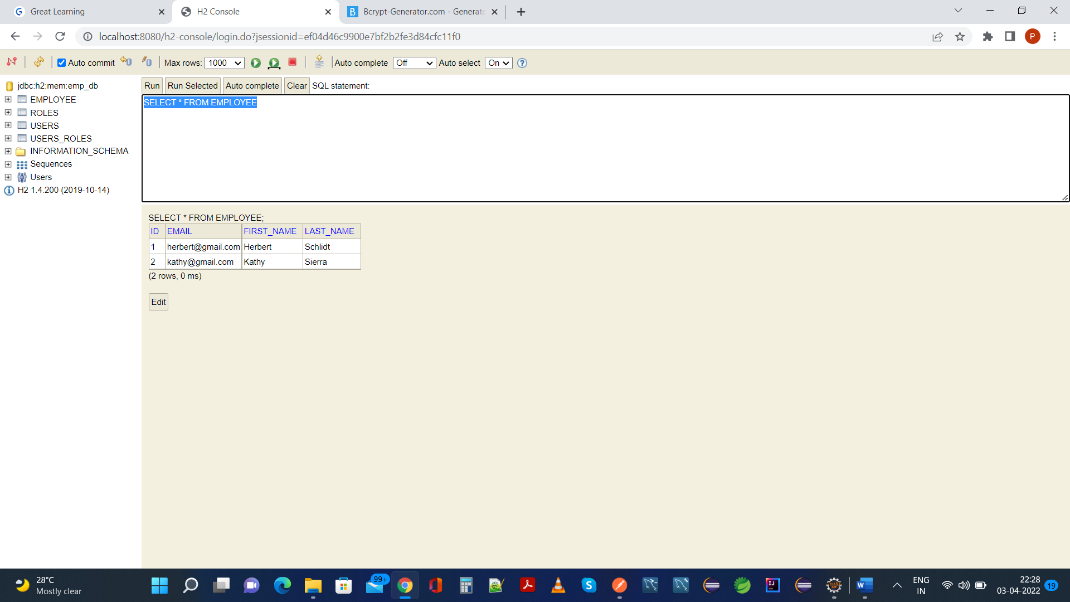

1. **Your application should provide an endpoint to fetch an employee by his/her first name and if found more than one record then list them all-**

**Postman:**

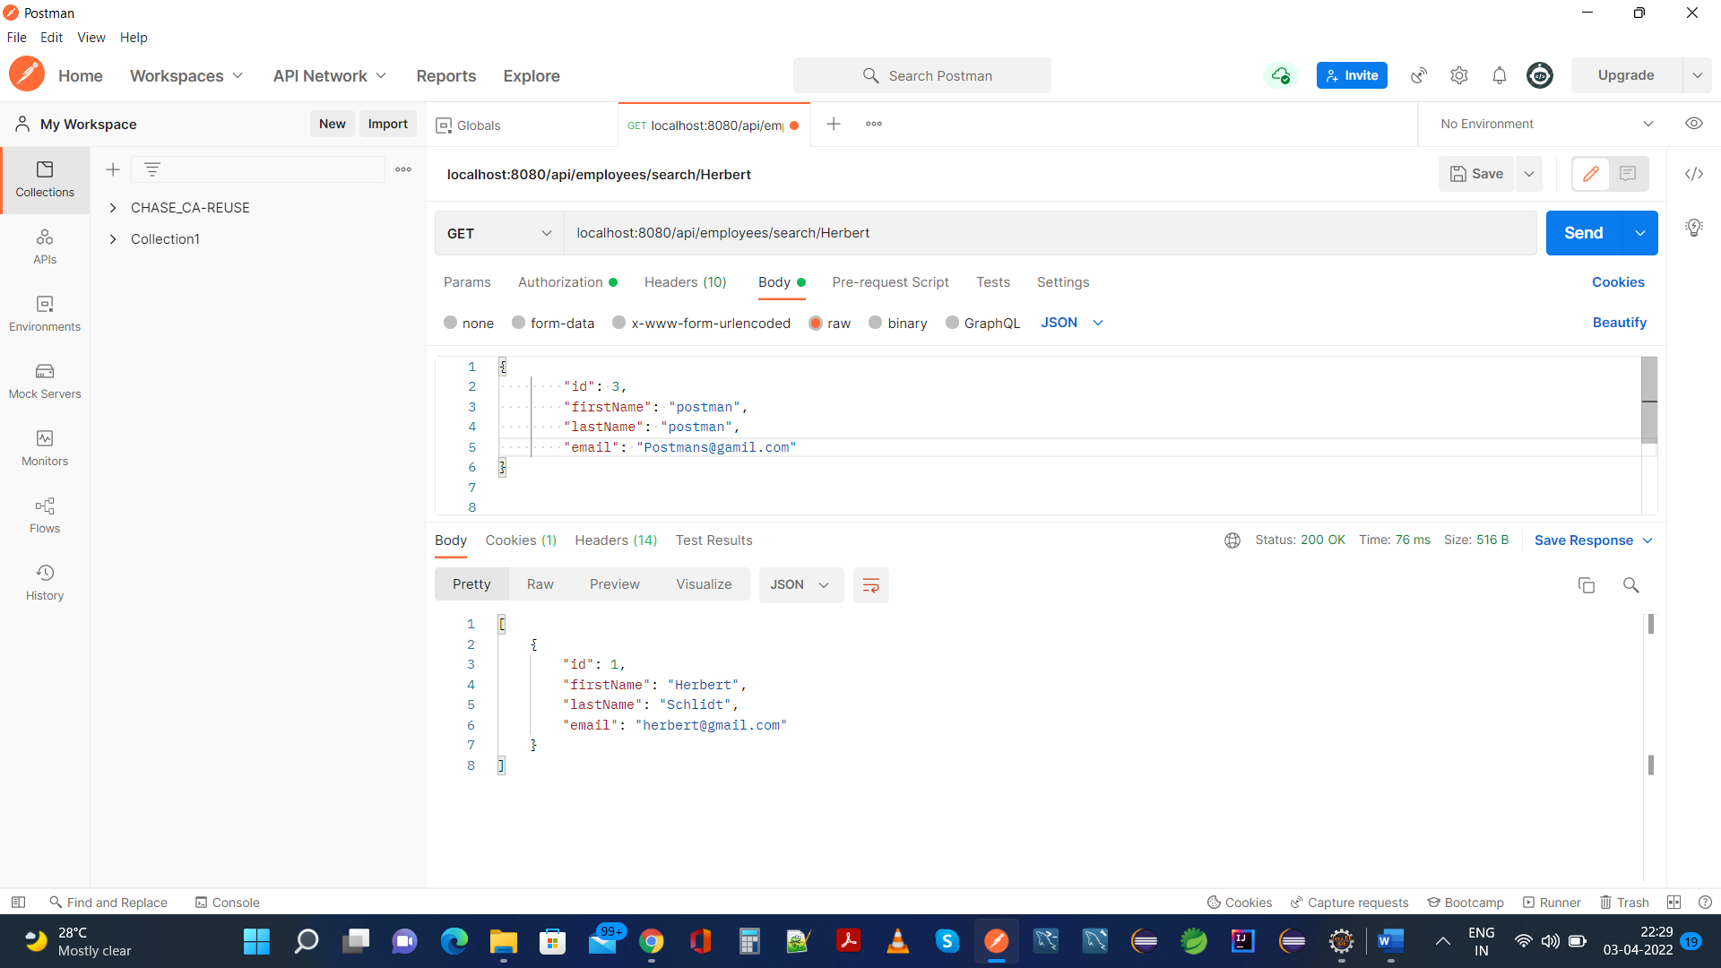

**Same as H2 Database With First Name As “Herbert”**

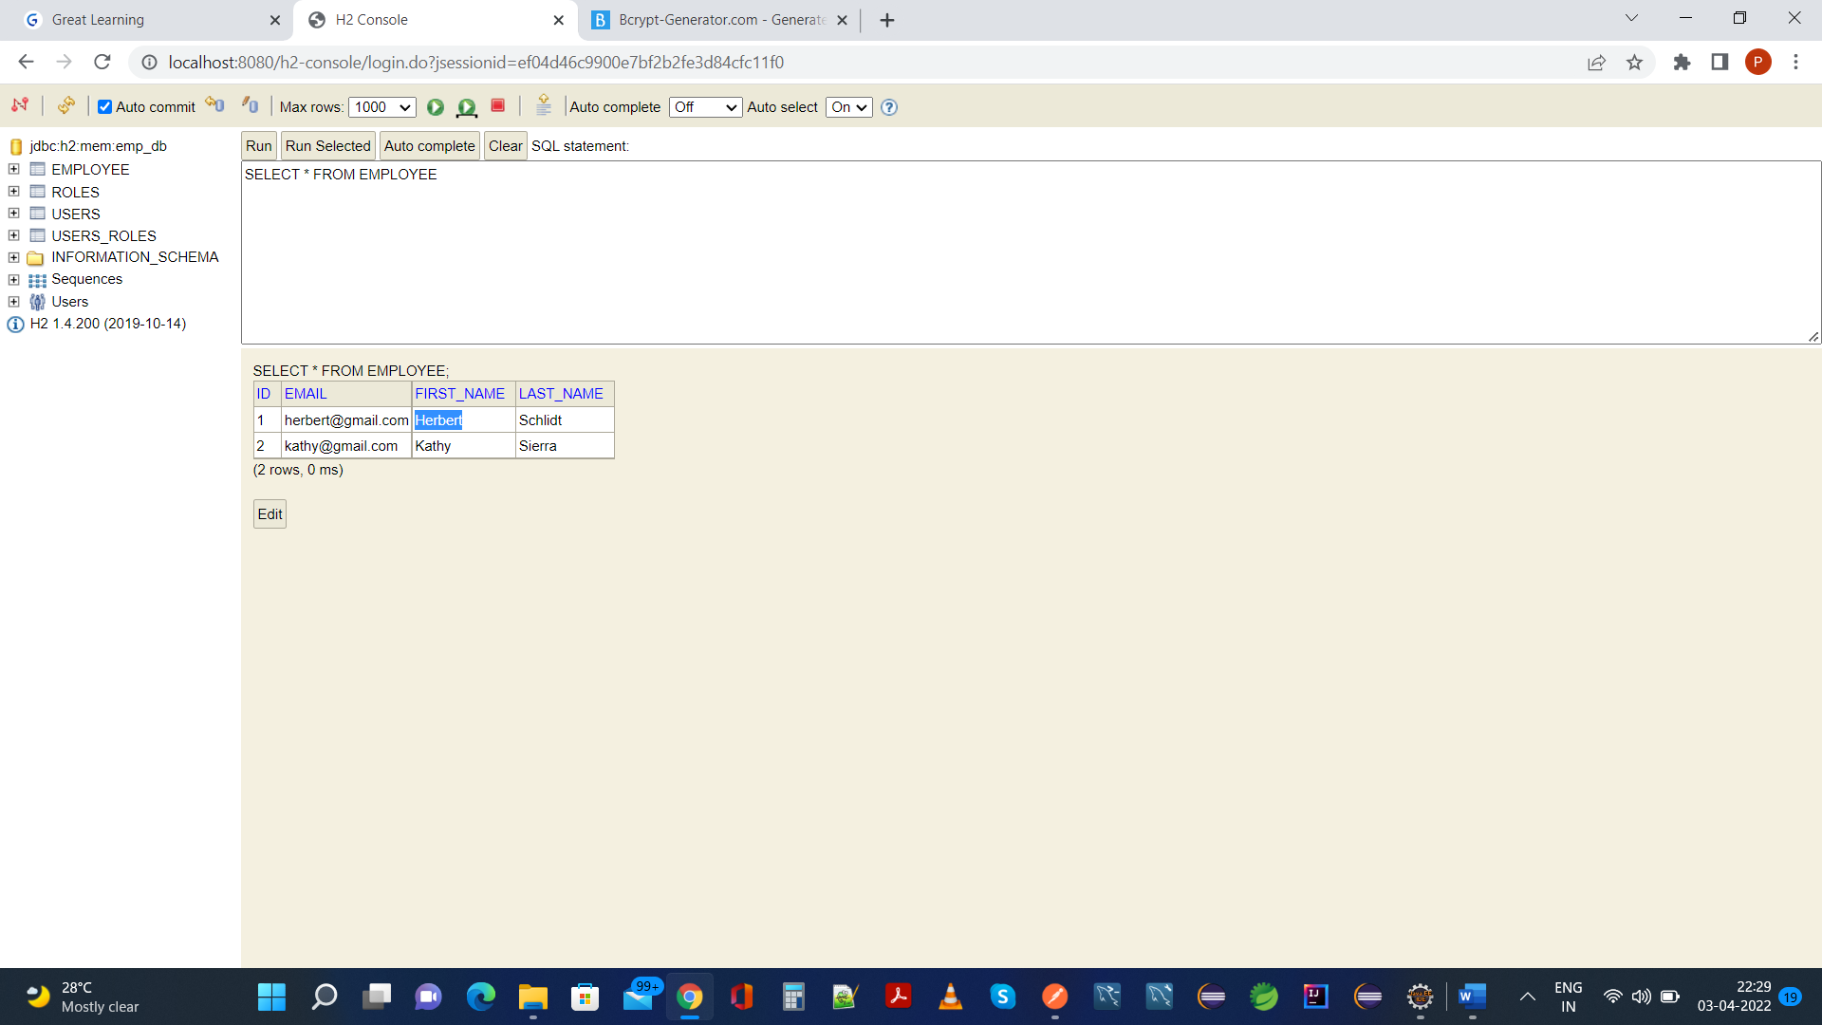

1. **Your application should be able to list all employee records sorted on their first name in either ascending order or descending order** .

**Postman(Descending Order)**:

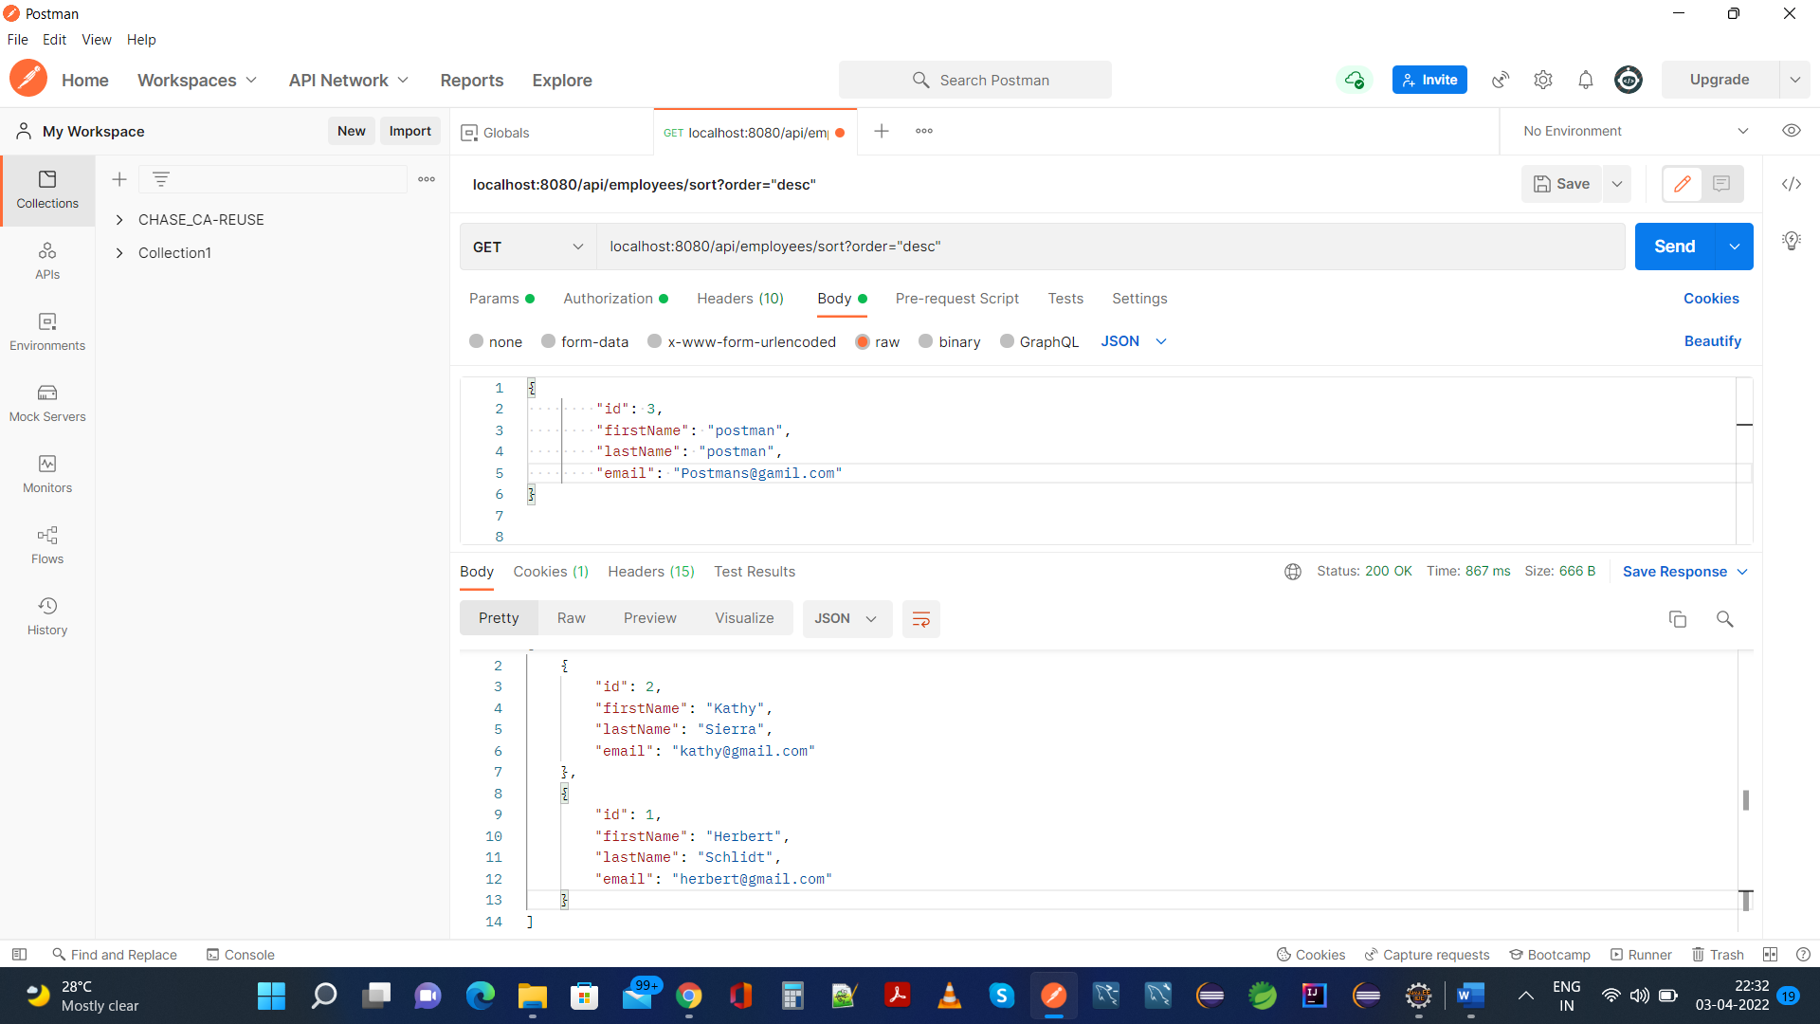

**Postman(Ascending Order):**



**CLOSING THE APPLICATION WITH SOME LOGS FOR REFERENCE:**

